Just another glorious day: Thinking outside the box

What follows is a diary of Sam, aka ‘the man from the box’. Sam is the main character in the ebook ‘Another Glorious Day’ and on his release from the confines of that text he started a blog. This diary is based on the entries in that blog. Dates have been removed and the posts have been put in sequential order.

The man from the box: Is that me?
Why continue to call myself the man from the box? Why perpetuate that label? Why keep all that going? Why not just use my real name (Sam)?
Mostly because it feels as if I can be two people at once. There is me – Sam – the private person, not wanting to share myself with the wider world; and there is the other me – the one the press hailed as ‘The Man from the Box’. This second one is the one that was put on public show and is the one I am trying to hide back away out of sight.
That label was stuck on me and it has defined me for the past several months so that is who I will be here, for now at least. Even making that decision puts me back into a box – the box of forever being labelled as The Man from the Box. It feels like Russian dolls: a box within a box within a box. Get out of one box and you think you are free but you turn out to be inside a different box; get out of that one and society has a whole new box ready and waiting for you ….
Maybe I think too much. Certainly I am clearly not fully over the whole ‘being in a box’ thing. What happened there is still inside me. I am making good progress but there is some way to go yet. It is taking time to readjust to being back in the ‘everyday real world’ box. On some days things are brilliant; on other days there isn’t so much energy. Not every day is another glorious day. Some are just that bit more glorious than others.
I am still living bits of days in some totally different timeframe. This new time feels as if it has edges that are somewhat rougher. Minutes clank; hours drop into place; days tumble heavily into night. It is a denser sense of time that brings an uncertain, halting progress with me not really knowing what comes next. I should be used to that by now.

Day by day
‘Take it one day at a time.’ If I hear that one more time I will scream. Life goes by one day at a time but just going with the flow of what life chooses for you has never been my style. I work alone (Well, I used to at least); I make the decisions about how to deal with that. I stay in control. If that hadn’t been my approach I would be in a different place now. I plan it out in my head; I do things to make the plan work; I think about everything (even at the risk of being accused of thinking too much). It is how I am. It is what makes me. It is how I make time pass (not letting time carry me at its pace).
It is a favoured phrase of the hospital psychiatrist; ‘One day at a time, Sam: one day at a time.’ but when I ask her if each one is going to be another glorious day she has no answer. She simply looks at me over the rims of her glasses and writes some short note in her book. It keeps her happy, I suppose.
Each day is one more day back into rehabilitation. Each day is one more day in which to go back over and over the same things in my head. I don’t know why my thoughts and memories are of so much interest. I am a specimen to be tested. I give them answers not knowing whether or not they are right answers – or even if there are any answers that are more ‘right’ than others at the end of the day: at the end of each day taken one at a time.
There are flashbacks. There are spiders and lines of light. There are explosions and doors. There is Dad and Emily and Jane. The others don’t matter. The flashbacks take me back there. Everything seems so real but then I have always had this issue about knowing what ‘real’ really means.
I have been encouraged to write; to get things down so they can be looked over. Obviously I can’t say too much. There is still the matter of official secrets and all that. Maybe this is all I should say for now. Maybe I have already given too much away.

The Coalition when the music stops
In my head I kept myself sane by doing mind-games. One was a variation on the game in the radio entertainment programme: ‘Sing the words and continue when the music stops; and then when the music kicks in again see how far off-tune you are’. I knew that the country had a coalition government. I then went off-radar and imagined where the politics would have got to by the time I once again had access to news/radio/TV/newspapers again (Hopefully only several months later).
I guessed that the coalition would be falling apart because of a range of disagreements. In reality this is only partly so – the will to be in power is too strong. Clegg has started to set out a path that sits nearer to what he laid out in the election debates (Poorer families helped by not having to pay so much tax – even if other families gain from increasing the threshold for starting tax payments; curbed a bit by higher taxes on richer families one way or another). There are cracks but they are small and surface ones – no deep fissures; nothing structural that a builder would worry about; nothing that a bit of cosmetic filler can’t fix. No collective sucking in on teeth and muttering ‘Oh dear, oh dear, oh dear: Whoever put that together. That will have to go…’ Still, it is some time yet before the next election. Once that looms, the new stories will be woven. The cracks will open. ‘Mind the Gap’ will sing out with every pronouncement. There will be cracks; there will be gaps. Maybe we will, by then, fall into them once more; fall for it all over again.
Some day, when I have the time, I will dig out videos of those election speeches and compare them with the lines being peddled now. I am sure there is a mass of intellectual fraud that has been perpetrated. Some sort of Crime against the Nation.
Meanwhile the personal news is that I am free to go. I can choose to organise my own life. It is a bit terrifying. I am not sure how it is done after all the regimentation, the confinement, the routines. Since I can do absolutely anything in the world I am going (having just got here) to get away from it all. I have stuck a pin in a map and chosen Vancouver.

Vancouver: a wonderful city
This was probably a good idea. Vancouver is billed as a postmodern city and it has a certain feel about it: downtown high-rise; old colonial heritage houses; art deco interiors; some modernist/brutalist concrete; Olympic village housing being sold off as smart flats; waterfront walkways - all mashed together. People going about ‘real’ life alongside film crews shooting car chases or filming demonstrations of people protesting on the steps of a (fictional) courthouse – which are ‘really’ the steps of the city art gallery (which, before it became the art gallery. used to be the old court house…). Fiction as reality as fiction. It is a city of masquerades.
It is a city that is both real and not real at the same time … and there is always the issue that what I am seeing as a tourist may not be what residents perceive who live here year-round (and that may itself fragment into perspectives from Robson Street with its designer shops, perspectives from the street dwellers of East Hastings, perspectives from the recent arrivals or older working class or First Nation citizens of Eastside ….).
I worried about flying – but that was no problem. Take-off was mid-afternoon. We flew in daylight over Greenland, over part of the wilder northern territories, over the flatness of Alberta and over the Rockies before swooping down to sea-level of Vancouver. If I had any doubts about coping with the metal-boxness of a plane these were offset by watching the scenery.
I booked into a great hotel – all art, jazz in the bar, a relaxed breakfast restaurant with newspapers to thumb through: realising that the issues in Vancouver were pretty much the same issues as elsewhere (Well, elsewhere in Western cities – not the same as the issues for the group of men who sat round my box each day in those times that I am trying to shake off but which creep up to ambush me to me at the least expected times).
I have been doing the guidebook stuff: The walk round the seawall; the wander through Stanley Park (named after one of the few famous ‘Stanleys’ in history); Starbucks coffee at the end of Water Street waiting for the Steam Clock to chime in its own unique way; the public art everywhere; the excellent public transport system; ice hockey on TV in a bar; the arty conversion of the old industrial units of Granville Island; the neat little boats bobbing from landing stage to landing stage; and so on. I have been doing what was expected of me. I always do what is expected of me. Always: Just one little slip, that was all. One unexpected move and it was all knocked sideways – but that was then: this is now. That was there; this is here in this city of freedoms. I have followed the guidebook. I have taken it all in. I have been taken in by it all.
At the first breakfast the cheery waitress said ‘Welcome to Canada’ but I’m sure she meant Welcome to Vancouver. This isn’t Canada – it isn’t Toronto, or Montreal; it certainly isn’t Winnipeg or Edmonton or the smaller towns of Nova Scotia or Newfoundland; and I am no expert but I am certain that it definitely isn’t Whitehorse or Yellowknife … and is a world away from the arctic settlements of places like Old Crow. Every day she urges me have a great day, just as if she really means it. Her training has been spot on. ‘Have a great day’. I try my best. I hope I live up to expectations.
Whatever: Vancouver is great.

Another Glorious Day? Definitely not one of my best…
Vancouver was great – almost pleasantly agoraphobic – with its spaces and its sense of controlled freedom. I chatted with absolute strangers; I sat in different bars and restaurants; I caught buses and the Skytrain. I wandered into shops and exhibitions. You can see why it scores highly on an international livable-cities index. I felt pleased with myself. Everything was going well - until the flight back.
It crept up slowly … sneakily … I didn’t feel its presence until it was far too late.
It was about halfway into the flight. The distractions had kept me going: The excitement of a takeoff into the dying light over water; the food; the drinks; the film choices. There was hustling and bustling; comings and goings. Sometime after that the cabin lights were dimmed and the window blinds lowered. I was back in semi-gloom. As I tried to sleep the sides of the plane started to slowly close in on me.
I put the blanket over my head and tried to visualise a glorious summer day. In my head I tried to make things open, airy, breezy but my mind wasn’t having any of it. I imagined open fields and the call of bitterns in misty reed beds as the sun began to rise in the morning sky. Gradually, wherever I tried to send myself to, the clouds rolled in; the darkness settled. I felt the chill. I imagined a line of light. I was back in the place I didn’t want to be.
Apparently I stayed hunched up for a couple of hours then started to patrol up the near aisle, behind the toilets, back down the far aisle. Round and round; talking to myself all the while. Someone offered me a drink and settled me in my seat. I drowsed off immediately and woke in an ambulance being whisked out of the airport.
I am back in hospital, not the ward I was on before but in a different part of the hospital altogether. The staff are more psychiatrists than nurses. There is a lot of talking; a lot of suggesting that I write my thoughts down (I was doing that already I told them); a lot of freedom to wander around within the confines of the building. I don’t know how long I will be here … It could take some time ….

I have a plan ….

I promised myself that I wouldn’t write anything else until I had something productive to say. There are different viewpoints on this. One is: If things aren’t going well then that it the very time to get everything out of your mind and down on paper. Writing as catharsis. Writing as cure. Writing as aid to wellbeing. It probably works for some people but it doesn’t work for me. All that time with only my own thoughts for company taught me a lot about myself. I know me and dwelling on things, running over and over the same negativities, doesn’t do it in my case. I need distractions. I need to move on. I need a sense that doors will open and a path will unfurl into the future. I need some music to dance away to.
So I haven’t written since that last brief note about the return from Vancouver. Now I am writing again: draw the conclusion that is there staring out from the page. I can’t guarantee an issue-free future. What I can say is that I have been working on a plan.
I have decided on four things to focus on:
1. Vancouver Gallery: I took around fifty photographs whilst enjoying my walks around that wonderful city. I have decided to go through them and select six or seven pictures that are more interesting to me than the rest – and then write a short account of what attracts me about each one. Why did that particular subject catch my eye more than the other things I passed on the walk? Why did I take it from that angle? Does the picture have a point of view; does it have something to say? And since there is little I do that isn’t for a purpose (All that training showing through again) does the picture-process have anything to say about me?
2. Art Sessions: I have always had this interest in the nature of art, the purpose of art. I have visited a fair few exhibitions in my time, not because I had to but just because I could – because they were there and might be of interest. In the same way that I have been reading up on the supposedly beneficial effects of writing as an aid to dealing with difficulties. I have also been randomly picking my way through articles on the curative effects of art. I have decided on an art course (for absolute beginners) and will do weekly exercises in drawing, painting, sculpture (of sorts), as well as going to exhibitions and reading the arts sections of newspapers and getting art books out of the local library. It isn’t a course run by anyone (well, not an external organisation), I suppose that I am running it for myself. I made links with an art teacher at the hospital and she has given me dozens of possible projects. How I take it all forward is absolutely up to me.
3. Politics: The discussions with the psychiatrist ended up with a decision that I need to come more out of my own head (He joked: ‘That’s not quite the same as going out of your mind, though’). Maybe it was all the philosophy degree stuff, maybe it is everything that has happened since. Whatever the reason I spend too long locked away inside my own head. Alone with myself. Observing the world but not being in it. I need to engage with everyday stuff. Politics is as good a place as any. What’s going on in the world and why? … and what has any of it to do with me. The aim is to read the politics pages of a daily newspaper (one worth reading) much more closely that the brief scan I am used to giving them. It isn’t about joining a political party and getting bogged down in all the machinations, the endless detail of meetings, the cut and thrust of public debate. Who knows, that may come later, but it’s not for now. Now it is simply about getting outside my own head.
4. Out and About: A bit along the same strand is the need to deliberately go out on walks, out on buses or trains. One danger is that I could easily stay in my room. I could find a way of arranging a small world for myself. I could cut myself off more and more and that is not what I want to do. I will schedule, just for myself – just because I can, a series of outings. I will find places I like to be (and maybe places I don’t like). I may find a corner of the world I can go back to by choice. I will be in the midst of others. I will just go as the feelings take me. I will let the journey unfold.
Writing it down: I will keep my recordings of how all of this is going – just for myself: Why would anyone else be interested? I will keep it close to myself .. there is always a tendency to drift away, to wander off, to float upwards. Always a tendency to elaborate, to make things up, to keep real things at arm’s length. I will be on my guard. I will be watching myself.

Vancouver gallery

I am not sure whether writing this is supposed to be some kind of therapy, or some pretense at being knowledgeable about the meaning of imagery in photographs, or whether it is simply a way of passing the time – an activity that is as good as any other at the moment.
The background to what follows is a range of photographs taken on my trip which, overall, had many positive feelings for me. Within that overall blanket of ‘niceness’ I captured (an interesting concept in itself) a wide range of images. Now, back home (another interesting concept) I have gone through a process of elimination that involved sorting the pictures into three piles according to the degree of connectedness, for me, between the image and my feelings whilst in Vancouver (as far as I can recall them this long after the event). The ones in the ‘most connected’ pile were saved, together with the borderline cases from the middle group. The rest were put to one side. This gave me thirty photos, with which I repeated the process, justifying each choice to myself. Those thirty were spread out in front of me and, again trying to articulate to myself any rationale, I chose my absolutely most relevant one, my second most relevant one and so on until I had just a handful in front of me. These weren’t necessarily the ‘best’ pictures of the lot, or even the most ‘interesting’ ones. They were the ones that triggered most reflections of my ideas and ramblings whilst over in Vancouver.
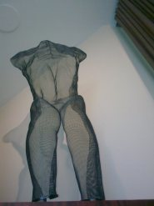
Body sculpture: This sculpture was in the lobby of the wonderful hotel I stayed in. The Listel. It was on Robson, the main downtown street, so was handy for all the things I had already decided to do; but the main reason for picking it was that it billed itself as an Art Hotel and, true to its word, was full of original paintings and sculptures. Just walking round the corridors was a great experience.
This sculpture was one of several things that I went back to each morning. I would simply sit and look at it for ages, finding more and more things of interest each time. What kind of things occurred to me on those relaxed observations? Clearly it was a body-part: a torso without arms or feet, and missing the head. So, from one angle, it was a part of a crime scene … a thing that demanded an explanation of how it ended up like that … and encouraged speculation of how a detective would work backwards from a discovery of such a body to work out the detailed chain of events that led up to its gruesome discovery by someone. Admittedly this representational, sculptural version wasn’t gruesome (no blood, no gore) but its discovery, tucked away in a corner of the hotel lobby, was still a shock, an unexpectedness, a fascination, a wish-to-know-more.
Tucked away in its corner the piece was, in one way, easy to overlook but, at the same time, was set up on a ledge so was itself doing the overseeing… a shadow peeking out over each new guest. It kept up its solitary vigil as transients came and went. It might as well have been some remnant of a former receptionist clinging on to the role from a ghostly perch on high. Or some attempt at capturing a Spirit of hotel-keeping, a lighter version of those more solid Greek and Roman antiquities, a reminder that coming and going was nothing in the faceless gaze of an everlasting ideal.
The dominant thing about the piece was its transparency. The net effect was of latticework; and yet the whole thing had its own solidity – solid enough to cast a shadow. An ambiguity in itself: that something of such substance could be constructed out of openness. Watching the changing light play in and out of the mesh, there was form and shape and substance whilst retaining its sense of emptiness, of being and not-being at the same time: of being and nothingness. Existing yet not existing; real yet not real. The very emptiness of its net structure creates something new, something with its own existence – the diffraction patterns that shifted and swirled as the viewer shifted position. Something out of nothing. Something and nothing at the same time. Parallax: paradox. Something about it resonated inside me.
The corner it overlooked was the small half-hidden part of the lobby that held the public internet terminal – itself a thing that only made sense as a portal to the invisible; an invitation to sit and be transported off without further human intervention even if it was so obviously just a dusty desk and silent terminal.
The web/net sculpture held a place of guardianship to a web/net escape-hatch used by transients to reconnect with the realities they had left behind. Like the terminal, the sculpture was a communication route – sans mouth, sans hands, but not quite sans everything. Far from dead; far from dumb; far from lifeless – but still a lifeless form, dead until interacted with, dumb until communicated with. There was a tinge of Zen about the whole thing. We spent a long time communicating – me looking intently at the piece, and the piece (in its own, rather mysterious way) feeding thoughts back at me.
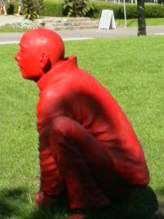
Red squatting man: Turn left from the hotel, zigzag down to the seawall, follow the walkway round the harbour and suddenly you might happen to come across a circle of men squatting on the grass. They seem animated, chatting across their circle. They have a full set of arms and legs – so no crime scene: this is everyday normality – men passing the time of day, telling each other stories that are more or less true, more or less elaborations on a reality in their heads, more or less absolute fictions.
They take you by surprise. You stumble upon them, but only if you take one path not another. You might glimpse them in the near-distance and be drawn into their circle. They might lure you nearer, tempt you to stay awhile, trick you into passing time with them that you had planned to spend elsewhere. ‘But why rush?’ they ask. ‘Why move on so hurriedly? Rest awhile, stranger. Linger with us.‘
You might end up being transfixed there forever as one more member of the smiling silent circle.
In the photograph there is just one man looking off into the distance. He squats like a frog as if he might at any second spring off, yet there he remains, unmoving and unmovable. The shot misses the fact that he is one of a group of silent squatters, eyeing each other up with looks that are not expressionless but enigmatic. The collective has been reduced to a singularity and this changes everything. He (It looks like a He) is alone, looking out; resting or ready for a race? There is a feeling of boldness, of power, of benign tension.
In this particular shot, at that particular time (but shifting as the day goes on or the angle changes) there is a shadow (looming over the man; casting a shade for him to rest in or casting a shadow over his existence?) and a distant pathway and sign (an indication that others may come and go in the near distance but his gaze will not falter; he will remain intent on what is in his head).
I sat as one of the group in silent meditation. I felt their tangible presence. I shifted position and sat directly opposite this one man, staring into his look, daring him to change his expression. I lost myself momentarily and became one of them. I snapped back and became one of me.
One link to Vancouver that this image held out for me was the sense of the surprise of the everyday. On my first morning there was a childlike excitement at seeing a floatplane come in to land on the placid stretch of water. I wanted to tell everyone ‘Guess what I’ve just seen …’ but of course to them it was an everyday thing. Another link was the statue being a representation of the strong community that had resettled from the west, coming across the Pacific: again a surprise to my intuitive Eurocentric fixed view that the way to Vancouver was from the East – the way I had got there. Beyond that was the thought of how this rooted community became the historical site of what was now a tourist, heritage part of the city. The vibrancy of a Chinese neighbourhood being close to tipping into nostalgic aspic: Circles of old men animatedly gossiping replaced by cast circles of statues frozen in the act.
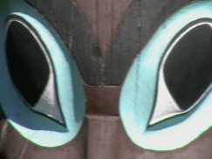
Totemic eyes: This picture was taken at one of the landmark places in Vancouver: the totem poles in Stanley Park. This, itself, threw up for me a host of things to think about. Stanley Park: An English park; a legacy from the British colonial governor Lord Stanley; with its Rose Garden and so on – as one stop on the tourist trolley bus route, as a place savoured by residents and tourists alike for the Sunday walk, the routine rituals of open-air exercise and relaxation. Yet, there as one of the focal points, harbouring in one of its leafy clearings, a collection of totem poles anchored out of context. Totems; iconic symbols of heritage but of otherness; markers of histories and territories; carriers of stories and myths intertwined so that one reality bolsters another. Reminders that the locality was once a site of struggle with nature, a site of daily routine for survival.
The poles carried meanings within their original communities. Here, clustered together, huddling for strength or standing as proudly independent as they can of the surroundings they now find themselves in, the poles carry sets of cultural meanings that have been shifted in time. The meanings were always mediated versions but now also carry overlays of what the modern tourist viewer brings to it all. Meanings are whatever we ascribe to the context. Are the poles meant as education, or as a parading of history before photograph-hungry visitors (and remember – I felt compelled to get my own shot of them: and a shot that didn’t even wonder if the eyes were those of a beaver or a bear or whatever, just a shot attracted by the eyes because of the electric blue colouring)? Whatever they are intended to be they are popular: iconic of Vancouver as it is now – whatever they may have been in the past.
The eyes are the gateway to the soul. The eyes on the totems were transfixing as if the past wanted to hold me in its gaze and assess me as fit (or not) to stand on those traditional lands. There were eyes everywhere, culled from different places, different communities: relocated to stare out somewhat defiantly – challenging me to come to terms with a different history, a different way of interpreting the world, a different sense of humanity. I felt small in their presence.
This particular set of eyes I found to be the most powerful. Others seemed to look mockingly, or accusingly. These eyes seemed to hold some compassion. I found them hypnotic. With the sun on my back we looked into each other’s gaze for as long as one of us could bear it. The eyes dominated what I saw. It is only when I look at the picture that I see the background detail, the patterning of the wood, and so on.
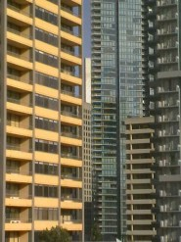
Tower blocks: Actually that is probably a wrong title – very English, very denigrating. There is a whole set of popular and academic studies done on estates, high-rise living, ideologies and community. The phrase ‘tower blocks’ has negative connotations because of these. But these blocks were strangely attractive. Maybe the better title would be ‘Apartment blocks’. But, even so, it’s not about the blocks but about the spaces between them … the gaps in which one might catch a glimpse of something else, something beyond the sides and edges of the colourful facades. In the case of Vancouver there were the almost secret flashes of sea and sky and mountain beyond the reflecting angular geometry of its urban front.
It is about seeing the gaps; glimpsing what is almost not there; rather than focusing on the obvious. It is about looking in hope, beyond the normal visibility. Things partially screened, partly hidden, almost secret. Things that can only be seen at an angle, out of the corner of your eye.
I asked about prices, about affordability, and about who therefore might live in such places (with their securely purchased views of water, of hills …) and who might be relegated to other shabbier dwellings over on Eastside (and whether that means insecure, rented views of semidereliction). Is this image emblematic of Vancouver – the view that people take with them when they leave the city – or does it belong to those who regard themselves as citizens?
The image has its own beauty – blocks of colour, modernist shapes, repeated angles. Shapes and segments, when one takes the longer view, when one sees in passing – but each segment, on closer inspection, when one stops to see, is a home. Each box is a site for daily decisions. People are structured together, boxed in but barely interacting. Each apartment is a box within a block; each block is a square on a grid of streets; that arrange to form recognisable zones … and so on. The apartments get changed round, redecorated, refurnished on rough cycles, on street layouts that keep changing as cities reinvent their arteries, their flows, their internal logics to neighbourhoods that get described in guidebooks as emerging more slowly, over decades – neighbourhoods that can be experienced immediately as you move around the city but also which are measured out in centuries as the heritage of an unfolding, ever-expanding city like Vancouver. Everything constantly changes on its own different timescale.
I wandered round neighbourhoods: Gas Town, Yaletown, Granville, Davie, Chinatown, Downtown, even venturing out onto the beginnings of East Hastings. Areas that were all neatly delineated on the tourist map, all segregated onto their own page of the guidebook. Each having its own personality: the spirit of the area. Each seemingly having its own purpose in the daily workings of the city; its own meanings for the people who live and work there – and offering different meanings for people like me, meandering through as tourists.
I suppose, in all cities, there are always different ways of experiencing the same physical spaces: the lifeviews of residents and the passing views of visitors; the perceptions of settled communities and of newcomers; of First Nations and of latecomers; of City Hall officials and of street-dwellers; of police officers and of career villains. Worlds that overlap and collide and co-exist and coalesce into a shimmering vibrancy that is Vancouver.
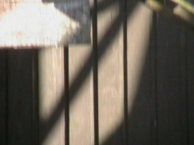
Fence: I spent a long time watching the change of light and shadow on this background. When I stopped watching I realised that I had spent more than an hour there: Amazing how long you can spend watching a line of light move across a background.
I took one shot as representative of the whole process that probably deserved more – a video maybe, to capture its richness – but which had to settle for this single shutter-click. After all, a film sequence would only have captured the one bit of transience out of the whole day, or what would have been recordable yesterday or the next day, in different weather. Each recording, however long or short, would have been a fragment of the totality; one of the millions of possible variations of the same reality. Whatever we record, or write, or think, or do, or attempt, is a mere fragment of what might be written, thought, done, attempted. Life turns out to be merely one version of a myriad of potentials.
At the same time this image was uniquely all I had before me at the time. I focused on the detail in front of me. The lines; the edges; the transitions from light to shade and back again; the patches of light in the shade and patches of shadow in the light; the hard fixed lines of the wooden slats interplaying with the fuzzier shifting lines of shadow; the straights and the arcs; the ambiguities of it all.
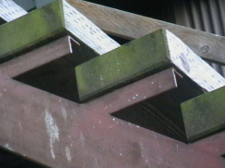
Steps?: The only reason that this kept getting through the selection process was that I have absolutely no memory of taking it – yet I must have done. There it is in the memory of my camera, sandwiched between a shot of the Steam Clock on Water Street and a shot of a strange little statue of Emily Carr. The camera has a memory that I do not have. How can that be?
I remember sitting in the Starbucks next to the steam clock, inside and warm whilst a knot of Japanese waited in the drizzle to take a photo of the clock as it went into its steam-driven Westminster chimes. A quarter of an hour later the sun was out (such is the changeability of Vancouver’s many microclimates) that I was able to get a shot of steam and clock without others cluttering up the scene.
I remember the walk over and down to the jetty and the bobbling little boat across to Granville Island. I wandered round the place and then got a bit disoriented trying to find a way back up to the bridge to start the short trek back to the hotel. It was then that I came across a statue of a woman, a donkey and a monkey (tucked on a corner just off Granville). The plaque explained all. I remember stopping, reading.
I remember Starbucks and the clock. I remember the bobbling boat and the loaded fruit stalls. I remember the weather, the seagulls, the flyover, the traffic. I remember the statue. I remember all that: So why have I no memory of taking this shot?
I am not even sure what it is. It could be steps, or shelves, or balconies. It could be a picture of things high up, from below – or maybe that is some illusion. There are diagonals. There is repetition. There are lines of light, blocks of darkness, hints of colour and pattern to break the monotony. I can see all that but still have no memory of taking it. Strange.
I read somewhere recently that our idea of memory has changed. It used to be that memories were stored, each in its separate box: Pigeon holed, to be revisited as a whole unity. My image is of a huge warehouse full of cardboard evidence boxes all labelled and filed, and some old half-forgotten guardian as the only one who remembers the somewhat idiosyncratic indexing system. A ‘lost’ memory is then a box not put back in the right place with the possibility of it being stumbled upon surprisingly, having slipped down behind other boxes – open the lid and there is the whole memory readily back in place. The current view is more complicated: Each memory has to be reconstructed (from fragments stored in distributed form across the brain) each time it is called to mind. It is a wonder, on this model, that more memories aren’t reconstructed differently. But how would we know? Each memory would feel that it is the right one, having no other memory to compare it to – we could end up living a life based on thousands of badly-constructed false memories … It would be no surprise that links get broken and it becomes impossible to put a certain memory together in that specific way, even if the fragments are still there, itching to be constructed into something … a ghost of a memory that doesn’t fully appear ...
Whatever the cause I find it incredulous that I have the tangible evidence of having done something that my brain has no memory of me having done. Scary.
Looking at the set of pictures spread in front of me I am struck by several ideas. These images are significant things; things that are heavy with meaning for me. They each relate to some reality out there on the streets of Vancouver but here, back home, out of context, they are abstracted things. They seem things I have grabbed, to hold onto, to mull over, to make something of them, to pore over and maybe read more into them than they deserve.
The pictures are symbols, totems: reference points to be gone back to, over and over again, (particularly if a person feels that they are losing their way). They become a mix of imaginations and remembrances, and when the time has passed they become assurances that things must surely have happened – because there is a photo in the album.

Art: do these sessions imply any progress?

True to my plan I have started on the Art journey. I took advice from the arts therapist at the hospital. I took an armful of books from the local library each day, scanning through them late into the night before exchanging them for another armful the next day. They were delighted: boosted their lending rate immensely.
The local discout bookshop had brushes, paints, card and paper all at bargain prices. I was a fully kitted out potential artist. I got at it, churning out daubs and dabbles; mostly rubbish that ended in the bin. Four I have kept. I think they show some sort of progress.
I had the radio on and the news was full of stuff about banks, fixing of rates, bonuses and the rest. The newspaper carried the same storylines and, in one article, came up with the view that ‘we have all now been well and truly bankered’. I love it when new words get inserted sidewards into our national vocabulary. Language is a thing to be stretched and tested at every turn. Anyway, I wanted to use watercolour to recount, through one telling picture, (just as older artists had captured the changing face of society in one wash of colour), the relationship between finance institutions and the increase in poverty that I was seeing day by day out on the streets. This was the rather feeble outcome – a twentyfirst century baglady hunkering down for the night in the closed-off doorway of a Victorian bank facade.
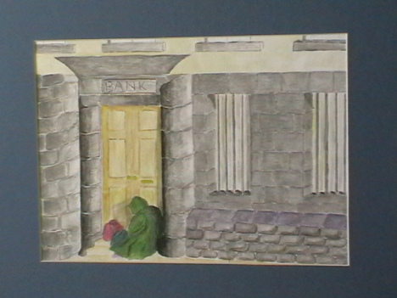

The second picture was another watercolour but one that didn’t try to make any point. The fire-escape attracted me when I was passing and I did a rough sketch before knocking out this painted version. What I was trying to put onto the paper was simply something about the patterns, the relationships, the lights and shades, the manmades and the naturals. It was a fire-escape, a shadow, a yellow door, a brick wall, a bit of soil and a scraggy bit of grass – but, at the same time, it wasn’t any of those; or it was all of those but only in so far as how they fitted together.
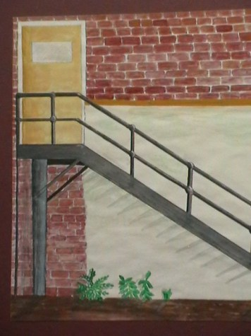
I tried something different. Something that wasn’t attempting to be at all painterly. (I think because I recognised that painting and I were not going to get along all that easily). I strolled round the shopping centre of one of the suburbs and came across this underpass. Again it was the sense of pattern,the shapes, the interplay of foliage, iron and concrete. The local council had done their best to make it seem attractive but it was still a spiral into gloom, a descent into the shadows. I would be Orpheus going into an Underworld. It lured me on but I stayed above it all and was content to capture the feeling in a photograph. An hour later, I had a colour print done at the photographer’s in the precinct. In the library on the corner I photocopied the small colour print into a larger, grainier black-and-white version. I was happier with this than with the paintings.
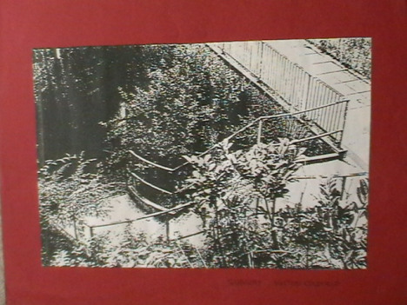
The fourth thing I kept was, for me, a real piece of art: Progress alive and well and living inside my head. Over a coffee, I had been thinking about home – or what might be home if it were still there: The house I grew up in as a child. That led me back to brother and sister, mother and dad. Which took me to influences; to growing out of things, to getting over things. Our daily existences dancing round each other within the confines of the squares of frontroom, backroom, hallway, bedroom … our own private little squaredances. Set pieces; bits of improvisation (not too much or we could be quickly brought back into line …).
By the second coffee I was onto Home as the place where walls and people interact. We shape it; it shapes us. Bits of it rub off onto us bits of us rub off onto it: Flakes of each left as lifelong traces on the other. I was thinking about how that old house in Accrington was more than just a place to live. It was a space to grow and relate. It was a space where I became Me. It became a space to burst free from, to spill outside of its confining walls and to go off to university – and rarely go back.
I started with the outline of the floorplan of the house (as I remembered it, at least). Onto that I put the outline of a body: part dancer, part murder chalk-shape. I got the proportion so that I was just spilling out, beginning to leak away.
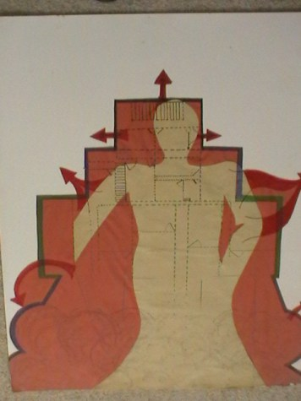
Progress of sorts? What do you think?

Mondrian in the city?

I have been at it again. Over the last week I have spent time in the public library looking through art books. I met Mondrian. I met other artists but Mondrian was the one I got along with most. It struck me that there could be an updated, very urban version of what he had been trying to do. He was all abstracted colour for the sake of it. I liked his style but it didn’t connect with my idea about this city, or visiting other cities, and me living an all-too-real non-abstracted life. I liked the blocks of colour though – and the black lines, and the grid-shape. Very boxed in.
I looked at some of his paintings more than others. There were plain white centres with coloured rectangles that invited me to read them in a certain order. I don’t know if this was what was intended, whether this was a required way of seeing into the internal mechanism of the whole thing. I don’t even know if there is any required way of seeing art at work. For me it was clearly clockwise; the eye being strained that way as well as the rectangles pulling themselves outwards towards the edge of the picture. The whole thing had an underlying tendency for spiralling – but spiralling into more control rather than spiralling out of control.
I looked at others and the change of colour or scale produced a different rhythm. The bright colours syncopated; the shifting patterns improvised. He was surely a jazz fan? And these weren’t things just tossed off in a few minutes. These weren’t just flashy ‘Here’s how I feel now’ paintings. Apparently he would work for months on a single painting. He would build up layer upon layer until he was sure.
It shocked me when I opened another book and there was a totally different set of pictures. I had to check I was still talking to the same chap; that no imposter had sneaked in and stolen his identity between books. I looked at the dates. These were very early paintings of his. Rubbish stuff in my opinion. You saw the kind of basic paintings I had done – these were only as good as those.
So when did the one Mondrian become the real one? I went back and forth between paintings and dates. I felt like some great art detective. I pinned it down to 1908. He did one good painting then, of woods near some place called Oele, and you can just see the other Mondrian straining to break through. It struck me because it was so similar to one that had been hanging on a corridor at the hospital, one that had recently been done by an up-and-coming Birmingham artist. This was in an exhibition, so I bought it. It was called ‘Forest in Decline’. I was an art investor!
Mondrian’s ‘Woods near Oele’ was a masterpiece and my ‘Forest in Decline’ was one as well. Both have streaks of brilliant colours that run down the surface. Bits of background show through where they are unpainted. Of the two I think I prefer mine.
I am diverging from my investigation: I focused on 1908 onwards and found a painting of an Amaryllis flower dated 1910, a Dune Landscape from 1910/11 and a neatly titled Evolution from the same time. These proved to me that over those three years he had evolved from his scrappy early stuff to paintings with a boldness that relied on simplified blocks of colour for the scenery or the flower or the person. This is when I think he started to abstract the essence of things in this way. Shortly afterwards he went off into swirls of lines before reaching the beginnings of his grids of colours. This was around 1914. His great innovation was to spread these across the surface so that there was no real edge to the painting; so foreground/background; no subject and field.
Mystery solved for me. I could focus again on the rectangles of colour; the geometrical grids. Art all boxed out. If he were alive today then he would surely have an urban edge to his work. If he were coming up with these colours and grids now then surely he would have road layouts at the back of his mind. I found a couple of paintings from 1930/31 that were just two black lines meeting at a junction, or three black lines forming a set of right angle. They looked like the survey maps we used to study at school. I found a white background with single yellow lines that prevented the eye parking itself in any one particular spot. By the mid-1930s he was turning out something that I could see was very close to a road map. He moved to New York and that fitted much more with their city grids. Inventive to the end (He died a couple of years later) he started to use rolls of coloured tape to make the lines instead of painting them. I put the books back and headed off for a coffee to think it all through.
Later that week I decided on a visit to Nottingham (All part of my getting out and about – you remember that I have it all planned). I picked up a street map. I spent a long time looking at the city-centre detail, not because I was lost or wanted particularly to find my way around but because the shapes began to fix themselves on my mind.
That sparked the train of production: Photocopy the street map and you get the black-and-white grid representing that unique place. Block out some of the fiddly little backstreets and you have the essence of the shape of that city centre. Enlarge until the shapes look right. Put blocks of colour onto the unique grid and you have a mondrianesque representation of the essence of Nottingham.
This could be repeated for other places. It sounded as good an idea as any other. The results aren’t too bad:
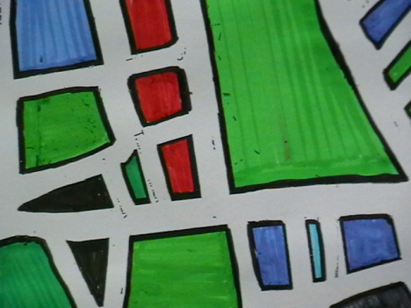
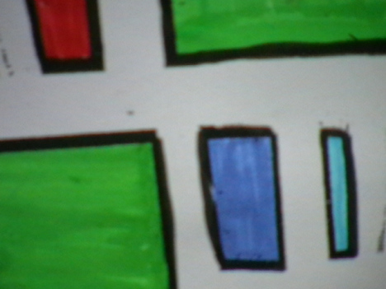

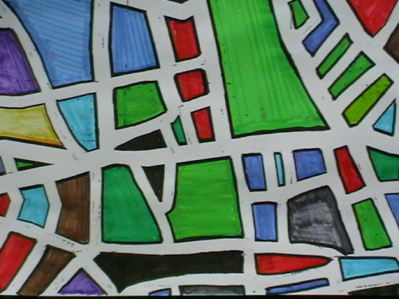
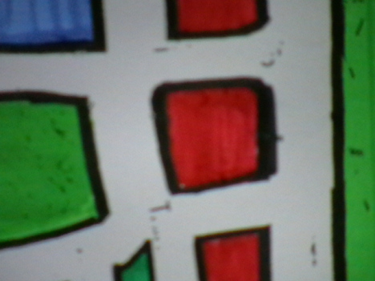
Why the blur? Why not stick to crisp and precise? Because cities are a blur. Because cities aren’t all crisp edges and precise lines. There is ambiguity. There is fuzziness. I wanted to show that. What do you think? Shall I pursue this? Maybe I’ll give Coventry a go, or even Derby. Then again, having now got my own version of the Nottingham street map maybe I should simply go there again and try to find my way around by blocks of colour, by simplified shapes. I could stand, staring at my mondrian-map, turning it this way and that until someone came over and asked if I needed directions – which is when I could start up a discussion on art and the city.
Or Picasso. Maybe I do a picasso-map of Nottingham (Think ‘Guernica’). Or maybe I do a lowry-map of there (Think stray black dogs, hunched over shoppers, drab buildings and you get Nottingham in all its Saturday afternoon glory). Or one of those aboriginal patterning of place as memory and dream and significance.
I’ll go back to the art books in the library and see who else I make contact with.

Am I an Artist?

I have been doing this Art stuff for some time now. I have given myself over to it; I have lost myself in it. Can I, therefore, think of myself as an Artist yet? I remember, from all those years ago, a poem by the scientist/poet Miroslav Holub. He asked himself whether he was a poet. He had written poetry (So he was a poet in the past). He fully intended to write poetry again (So he will be a poet again in the future). This implies that he can only think of himself as a Poet when actually writing poetry.
By this logic there is a fragment of me that is (or might be) an Artist – when fully giving myself over to doing Art. At those times a part of me acts as an artist; other bits of me act as other things. The skill is holding it all together. I remember, from those same university days, a lecture I dropped in on – about this guy Ervin Goffman and his ideas about the presentation of Self in everyday life: life as a performance. The skill in such a performance is not to get stagefright, and not to play too many parts all at the same time. I have it all under control. I am One, unified, united, integrated … pick a word; any word.
So, when I have been busy performing as Artist what artistry have I been dabbling in?
There have been paintings. There has been sculpture. Let’s talk about the paintings and leave the pottery for another day.
You already know about my thoughts on Mondrian and the city map. I thought some more about it and read about some more artists. I met up with an old friend from the past: L S Lowry. It’s good to stumble on people from your past. As a child I looked at so many of his pictures: Northern, matchstick-men, little black dog somewhere in a corner. He was of an age that has passed. He was a recorder of industry. He snapshotted little people with ordinary lives in dark settings. If he were alive today he would still be driven to paint and still be interested in capturing the human existence but it wouldn’t be hordes swarming into mill gates or huddling en masse for the enjoyments of occasional days off. He would get high above the crowd and look down to capture their swirlings in and out of shopping centres. He would be the picture-scribe of consumption rather than of production. He would be a man of the people of today – the mass consumer. How could he be anything else?
In the painting room at the hospital I have been doing stuff to capture ideas of life, death and resurrection. Not overtly religious stuff, just things that try to bring those ideas out of my head and onto canvas or board.
There was one picture called Phoenix Rising. It was heavy on texture, heavy on swirling around, heavy on the idea that something can arise out of something else. Here it is:
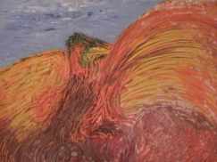
There was another, quite large painting, done with household emulsion on board. Geometric, angular, about relationships of one thing to another. When I was doing it, it was just patterns from inside my head. When others looked at it they saw patterns that meant something to them: a pregnancy, something phallic .. and so on. Here it is, make of it what you will:
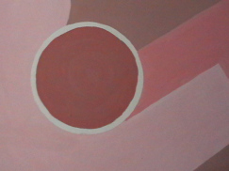
I think I am gettting closer to being able to think of myself as Artist. That is a fragment I hold onto. Another fragment, one I am working on, is me as Writer. If that works out I will be able to say more about it. For the rest I am a complicated mix of Patient, Tenant, Wanderer, and other things …. but all held together, as One, in my head.

A Sunday stroll through Birmingham – or was it New York?
Things are going well at the moment. I can feel old thinking patterns slotting back into place. My mind no longer feels like a foreign country. I am more at home in my own head.
I have been getting out and about more. Runs through the park; walks through the city centre. Ordinary stuff: stuff ordinary people do. I am trying for ordinary just to prove that there is nothing special about me. I have left all that special stuff behind temporarily. I may go back to it; I may not. For now just being ordinary seems hard enough.
I still do the art but dwelling any further on that would edge towards boredom. You’ve seen enough to know what I can do. It isn’t my strong point but, then again, I am not quite sure what my strong point would be these days. It used to be that I could manage alone. I could go off for days relying only on my intuition and skills. I didn’t quite fit with the others. I was not the gregarious one, I was the solitary one: the one in the corner thinking about what tomorrow would bring. I was the one who could be relied on to be reliable – until that one unreliable night when I tripped over the enemy in the dark and the whole box-thing started.
But let’s not rush back there. I had enough of it at the time. Let’s stick with the me that is who I am now: The me that wanders around Birmingham. You might consider that as being trapped in a different kind of box but to me it is absolute freedom.
On one of my little wanderings I picked up a booklet about the Book Festival. It seemed to be lots of talks, lots of people sitting in a room listening. One activity stood out as different enough to be worth a try. It was a Sunday walk through areas of the city pretending that you were walking around New York. Off-beat enough to only attract a small group. Off-beat enough to draw in people like me.
I turned up without booking, just to test it out. There were only half a dozen people, so easy enough even for me to manage. It felt like a good day for a stroll.
The couple of people leading the group tried hard to get us to imagine we were actually roaming districts of New York. As we walked people chatted in twos and threes. Occasionally people would break off to take notes for some later writing. I took photos.I didn’t intend to do any writing (although I may have a go later if I feel like it) but I did try to get in the spirit of the thing, pretending that the photos I was taking were pictures of New York.
I chatted with one guy, I think he said his name was Geoff but I am not that good with names. A few days later he sent me some writing he had done. I suppose it was quite good if you like that sort of thing. You can read it yourself and see what you make of it:
www.thewordsthething.org.uk/?p=229
As we walked I could see Geoff”s mind working: scooping up images to be worked through later in words. I wasn’t sure that I liked the idea of being looked at as an object to be churned into a story. I decided to get in first. I got my camera out and started taking photos of everyone. ‘Pre-emptive where possible’: part of that training I still go back to.
I got some strange looks so went back to walking and talking. It was a good day.
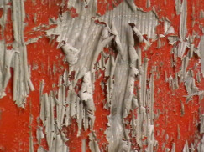 | 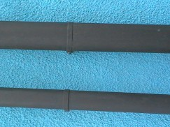 | 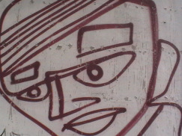
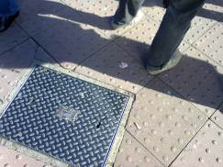 | 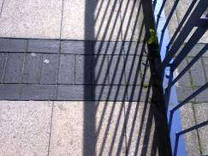 | 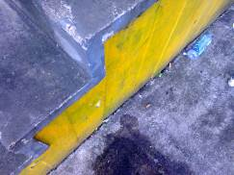
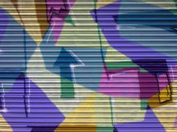 | 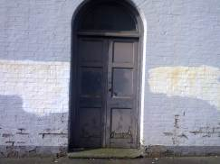 | 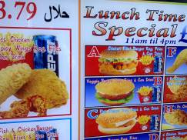

The ambiguous hatpin of great aunt Maud
As a break from the art sessions I switched to a few sessions of creative writing. Last week it was poetry. I didn’t really get into the swing but did give it a try.
The ambiguous hatpin of great aunt Maud
She died quietly enough
with a poor legacy
laid out on the best front-room table;
grandchildren holding back
from picking over the leavings -
but I see what I want
and stake a claim
on my childhood.
It had always caught my eye,
a special thing;
now, freed from her,
seeming to be so much less.
Glass not pearl
glitter not gold.
More false than real
but holding me to her even now.
She would recount the story:
It was the best he could do
from the trayful of ribbons;
this single hatpin
with treacherous spike,
gaudy enough
to turn a coy girl’s head
which she had worn, in memorium, eversince.
I could have done better but the others in the group seemed quietly impressed. I know that I could have done better. There is always ‘better’. ‘Better’ is what sustains us day after day.

The Red Notebook: Riding the Vortex
Time has rushed past me. There has been no time to keep up with it surging all around me. I have been in chaos. Life has lifted me and carried me along helter-skelter. Climbing, ratchet by ratchet, to dizzying heights then plummeting at stomach-stopping speed; up and down the rollercoaster. I thought it had been a couple of weeks since I last wrote things down but it has been several months – or at least several months since I wrote anything coherent. It has been life at a different speed. It has been life riding a vortex.
It turns out that the manic furiousness of it all was a side effect of the medication. I missed a couple of hospital check-up appointments and had to go through the whole process of getting new ones. By then it was too late. By then I was well past the stage where things might have been checked – where my erratic behaviours might have been stopped in their accelerating tracks.
At the time, I had little idea of what I was doing. Even now I have little recollection of what I did. Those are lost months to me. There are fragments and images; but little that adds up to any proper sort of account. No account; no balance; no bottom line. Just expenditure – of time, of frenetic energy – with little idea what it was spent on so lavishly.
Once I had come out of it all, everything felt different – as if I was in someone else’s life. The room was rearranged. Things were not where I expected them to be. Things turned up unexpectedly. There were scraps of paper full of scribbled nonsense – screwed up at the back of drawers, stuffed down the side of chair cushions. There were a couple of garish paintings that scared me so much I have destroyed them.
Piled into one corner I found a set of books that I have no memory of buying. I have spread them out along the skirting board. There are a couple of books on contemporary art, a small stash of spiral-bound notebooks (some blue, some black, some red), and three translated novels by Hungarian writers.
I have the Red Notebooks in front of me. There is only one that has writing inside. It seems that I had been writing all along. It is like reading someone else’s diary. There are words on the page. I know that I wrote them even if I have no real memory of doing so. The handwriting is clearly mine but the words feel like someone else’s. It jumps around and, in places, doesn’t make any sense at all to me now. It must have made sense in my head when I wrote it but I was in a different place, moving at a different speed, then. It is like something in translation.
I think it must have been written in February. The heading is ‘Life in a Time of Snow’. Here is an extract:
Snow again today. Snow every day. Blizzards and blizzards. Ideas tumbling slowly, carried on air currents. Drifting. Piling up in almost-forgotten corners of my mind. People could get stuck in there if not careful. They would need to dig themselves out. The coldest winter for years. They told us the globe was warming and yet here we are, snow-blind.
The snow has settled. I am unsettled. Looking out on the brightness, the whiteness, is painful. I keep the curtains closed as much as I can. I stay in the house. If I go out I may never find my way back. I may be gone some time. I would end my life as a wanderer, an artic albatross, floating round and round the world on outstretched wings – ending as a deadweight round the necks of all who know me. So I don’t go out. I stay in. I have a good stock of food.
It is cold outside and cold in here. The TV people talk about 1963 and 1947 but they are history to me. There is just here; now; what is in my head at this precise minute. Nothing else matters. On the TV now is a report of a man stuck in his car for 12 hours. I know how he feels.
There is nothing to do but watch the snow when it falls or pace round my room. I walk slowly so that I don’t use up my time in here before I am ready. I don’t want to be taken unawares. I never did like surprises. I need to be prepared for whatever happens next. I am prepared for being stuck in here for ever.
I pace round slowly. Measured. Measuring out the length and breadth of my life. I set up routines. I always go anticlockwise. The normal thing would be to circle clockwise but this gives me a different angle on things. It is also a way of counting down each circuit: 11, 10, 9, 8, 7, 6 …. All the way back to the zero of a new start; the nothingness of each new beginning. It is the chance to take life over and over again. Not making the same mistakes; not being taken unawares; not falling into the old traps.
There is a moon tonight. Full. Bright on the snow. I find myself being transfixed by the glistening surfaces. If I stare too long I see faces. I see Dad and Sean and that dangling little sister of mine.
I need to go out. I need to leave this room and wander amongst people but I can’t bring myself to do that. In here I may go mad. Out there, in the crowds, I might stumble across a ragged band of renegades; I might trip over people who will change my life forever. Safer in here, I think. For now, at least. Maybe tomorrow I will go out. Maybe ….
Maybe I started to go out then – last February. If so, I have no real memory of where I went or what I did except that I must have bought some books, and things in the blue notebook suggest that I went to an art workshop – I am still reading through that; still hoping that it will trigger more fragments.

The Blue Notebook: An attempt at contemporary art
I have been thumbing through the Blue Notebook. It has all kinds of scribbles and half-finished drawings in there. There is no way of making sense of any of it. Whenever it was filled was clearly a time of frenetic, manic energy.
Then, right at the back there are a few pages that are lucid, articulate, knowledgeable. If it hadn’t been in my distinctive handwriting I would swear that it was someone else who had written there. It feels like some half-academic essay from some art student. It doesn’t feel like me. Maybe there are more than one versions of Me. The one that scribbled away in that blue book was a me that had read up on art, had visited exhibitions, had been out and about, had signed up for a workshop (presumable with other people) – a Me that had produced a finished work of collage that looks remarkably good pasted into the back cover of the notebook. It was a Me that I had little knowledge of.
I read and reread those few pages, still unable to recall having written them; and still unable to believe that I had done the things it said, produced the picture pasted there, and sounded so with it. It still feels like a different Me:
I heard a question recently: ‘Can there be the idea of progress in contemporary art?’ Turning this upside down (or back to front) you get: Can there be pieces of contemporary art that can have their layers slowly peeled away, as in some kind of archaeology, to reveal where it came from?
I had picked up a leaflet for a series of workshops on Understanding Contemporary Art. On a whim I turned up for one of the sessions. The theme was collage and the workshop leader talked for a while about appropriation; borrowing; assembling found elements; using contemporary media for sources; what the artist brings to the work; how hard to expect the viewer to work; postmodernism, playfulness and the lack of grand narratives etc. I almost understood some of it..
In the same building there was the exhibition of contemporary work by graduates from local art schools. We were sent off to look at these and to walk round the building’s main gallery to find stimulation. I walked round as fast as I could. There were only a couple of things that made me stop and look twice at them. One was from the New Art exhibition (‘Entropy’ by Lindsay Booker) and one from the Barber Institute’s permanent collection (‘Composition with Fruit’ by Fernand Leger).
As part of the workshop there were some booklets scattered around and I spent a few minutes looking up Leger and making notes. He developed his early work in the context of cubism – his own style being called ‘tubism’ because of his focus on cylinders etc.. His work became increasingly abstract, with blocks of primary colours. He spent the first two years of World War 1 at the front and this influenced his art, making it into something mechanical (‘machine art’). After the war he was part of ‘Purist’ art – flatter colours, bold black outlines; and later, as part of the postwar trend to ‘return to order’ his work became more organic. By 1938, when ‘Composition with Fruit’ was painted his work was warmer, less over-mechanistic but with some remaining hint of machine parts. ‘Composition with Fruit’ followed in the tradition of Still Life but updating it by using techniques that were contemporary at the time – geometric forms, blocks of colour, incorporation of items from consumer culture, celebration of machine age tempered with organic imagery (the worms in the fruit, hinting at impermanence etc).
The ‘Entropy’ picture from the New Art exhibition was large, monochrome, pen and Japanese ink on paper. There were two levels to the picture: the overall image and the intricate, elaborate detail. It was intriguing and a bit disturbing; confusing to the eye. The marks cascaded, lava-flow like. It reminded me of earthquakes, tsunamis, tectonic movements, detritus, apocalyptic reshaping of landscapes. The text from the exhibition related the picture to alluding to ‘The Great Wave off Konagawa’, 1830, by Hokusai – a painting that I had first come across at university and which held some significance for me.
There were other exhibitions being written about in the newspapers on the workshop table. The Tate Modern was promoting its exhibition by some woman called Saloua Raouda Choucair – worth a trip of only for the name. She studied in the studio of Leger and was a pioneer of abstraction in Lebanese art. The article had an accompanying picture. It was ‘Paris-Beirut 1948’ – blocks of pastel orange, green, blue. Her work was disrupted by the later civil war in Beirut (some canvases having shrapnel holes in them). War disrupts so many things. War takes peple to places they never meant to visit. Sometimes it cruelly leaves them there.
The other artist in one of the magazines was David Hockney: drawing/ painting trees and pathways in his native Yorkshire. The magazine was full of pictures of his paintings and drawings. I photocopied a couple of these.
I had my choice of materials for the workshop – and it was material that (to me at least) had a number of connections across time and place. At the back of my mind there was still that idea of building up layers that might then be open to some form of archaeology:
The collage I worked on for the next hour was built up on a template from Leger’s ‘Composition with Fruit’, with some blocks of colour coming from a copy of Choucair’s ‘Paris-Beirut, 1948’ pasted into the lower corners. The worms and fruit from Leger’s picture were kept, by pasting in cut-out prints of Leger’s painting. The rest of the space was covered with cut-outs from a print of a photograph of ‘Entropy’; and some of the photocopied Hockney pictures. When I stepped back to look at the finished collage I knew I had arrived at something I was satisfied with. I will paste it into the back of a blue notebook.
This is the picture that was pasted there:
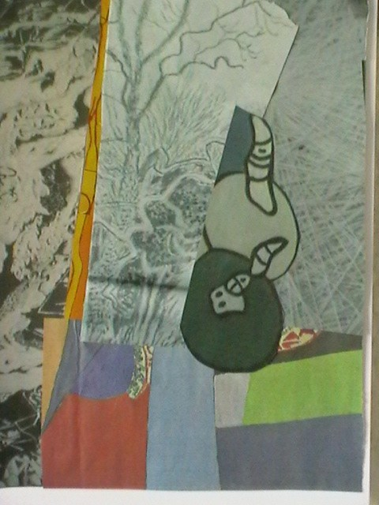
Not bad – considering I have no memory of doing it and considering I thought I knew nothing about contemporary art.

The Red Notebook: Clearing clouds and an oversupply of daffodils
The stuff in the red notebook carried on much the same as before: pages of ramblings. There was a slightly more coherent section mid-way through that must have been written in spring:
I went to the local shops today. That is the first time I have been out wandering around knowing what I was doing. I must have been out before because I never ran out of food but it is all too hazy to pin down any definite journeys.
Today I felt in control. It was as if the world had temporarily slowed for a while and I could get a grip on where I was and what I was doing. It no longer felt like stepping into a torrent of sensations and being swept away. I took things slowly but the way people reacted it was as if, to them, I was still on the hyperactive side of normal. They stepped out of the way; they gave me odd looks; most didn’t answer when I said Hello. I was charting as steady a course as I could. They were keeping well clear. Probably for the best.
I came back with food and basic supplies but I also filled the living room with bunches and bunches of daffodils. It was the colour. They filled the room with a brightness, a glowing happiness. They lifted my spirits. I only have one vase so the rest went into pans, plastic pots, anything I could find that would hold water. There must have been hundreds of daffodils.
I have a half-memory of seeing the flowers in a little florist shop off the High Street and thinking, ‘If I were Van Gogh and those were sunflowers I would take armfuls of them home.’ I am no Van Gogh and they weren’t sunflowers but the feeling was the same: they were stunningly emotional for a reason that was buried inside me. I had to have them. I had to capture the beauty and keep it with me. Since I couldn’t paint a small bunch I spread he whole lot round my small box of a living room. It was a way of transforming the place; a way of changing it from nothing to something; a way of transferring something of me onto the closed-in breathing-space.
The notebook carried on for a few more pages about the daffodils. My life, for that short period of time, was Daffodil through and through. Nothing else seemed to matter to me.
There is an entry a bit later that gives clues:
Someone keeps leaving messages on my phone about missed appointments. It is the hospital. Since I don’t have any record of when I am supposed to turn up there how do they expect me to know about appointment days? They ask me to contact them but when I get round to phoning the number I get a recorded message saying to phone back in office hours. I only remember in the middle of the night when I have had a few hours’ sleep. By the time the day gets itself going I am back to being caught up in everything else.
It seems that I missed at least two appointments. A Community Nurse turned up at the house one day and got me to the Medical Centre to make an immediate appointment. She then drove me to the hospital and waited until I was in with the doctor. They did a few blood tests whilst I waited. The medication was changed and it was like a miracle cure. Later that day the fog had lifted and I could think again. Time slowed back down to its normal pace and I had a proper meal and a bit of sleep ‘under observation’ before the doctor decided I was well enough to make my own way home.
The Community Nurse came a couple of times and talked to me about ‘making progress’ and ‘moving on’. I’m not sure what she meant. I am all in favour of progress but when you are stuck somewhere can you simply move on? Not in my experience. In my experience you are pinned in place. You are where you are. You are transfixed until some outside agency remembers you. When you have been fixed in the same place for too long how is it possible to leave it all behind? It is part of you. You carry it with you. It is your friend and companion for life: an unshakeable shadow trailing behind you.
The Red Notebook tailed off shortly after that. There were just a few prosaic entries – the diary of an ordinary person; the diary of a nobody.

Politicians lie – it’s their job; but that doesn’t mean we have to put up with it.
The Black Notebook was something I remember writing. I remember the anger; the frustrations; the impotencies:
The heat of summer, at last; and it may last, it may not. British weather is fickle that way – changeable, two-faced at the best of times: blowing hot and cold. You might expect it to have produced a British character that mirrors it – a people who are devious, duplicitous (a word I love to use), who would lure you on with false promises then pour cold water on all your hopes– just for fun, just because they can. It doesn’t seem like that, though. It has produced, it seems to me, a particular kind of stoicism – a willingness to put up with far more than is reasonable, a willingness to be put upon (even a perverse pleasure in seeing things through whatever the weather).
The common man and everyday woman go about their business assuming that they have no right to expect anything better than what life throws at them. They are generous-spirited, in my experience: willing to help out, willing to step in, willing to take things on: a battling, resolute kind of character – not quite the full John Bull, but certainly the helpful, deep-eyed collie; the friend in need, at the last resort. I am letting myself get swept away: weather to collie-dog in one sideward move. I need to stay focused.
I can understand it of soldiers; we are trained that way. We stand our ground. They Shall Not Pass. We form a thin red line in the sands of some out-of-the-way place that most people don’t really care about, and we die doing it sometimes, and we do it because it is our duty – because we are told that the world depends on it. We don’t know what the real truth is, and we joke about the officers and the politicians mixing up arses and elbows but we do their bidding when the order is given. It is what we do; it is how we are. It is all we know.
The trouble is that I don’t know if I am still a soldier- a real soldier. I am on the Army’s books. I am at their call – but they would be very unwise to aim a call at me in my present state. I am also on the books of the hospital. They call me. They send letters to me about this and that appointment. They do tests here and there. They fiddle about with medications and hope for the best. I, on the other hand, sit here and take it. I, who once was active duty, am passive recipient. I take what life throws at me. I have become a common man. I have accepted my lot.
The ones who don’t seem to fit his bit of amateur anthropology, the ones who seem to make the weather rather than be subject to its vagaries (Another nice word …), the ones who can afford to not be one of us – are politicians. This insight struck me the other day and I can’t go back to seeing things other than in those terms. Politicians lie to us: it’s what they do. OK, a bit harsh; not all politicians. Some are run-of-the-mill lobby-fodder. Some are constituency community workers. Some, however, are professional liars. It’s what they do; it’s who they are – and they get away with it.
Cognitive Dissonance: one of those lectures I sat in on at university when I was supposed to be doing something more useful with my time. That is the mental illness that the top politicians suffer from.
In the election TV debates I remember David Cameron setting out his logical beliefs why the state interferes too much in peoples’ lives. He was all in favour of getting rid of centralism and going for local solutions. ‘Localism’ was everything (and nothing, as it turned out). Once he realised that Localisation might mean local democratically-elected councils deciding for themselves, the goalposts moved and it was more about ‘local people deciding, not being held back by bureaucratic councils’ – but once people started saying that they didn’t want the bedroom tax, or the disability assessment regime, or any number of things – then it all switched back to Nanny Government knows best … It’s a wonder their collective cabineted heads don’t explode …
It’s not as if these people are the sages-of-all-time. It’s not as if they are held in high regard for their thinking skills. They twist and turn; they duck and dive. They are the chameleons to outdo the best shape-shifter. They are straws in the wind. They are glib-speakers; snake-oil purveyors; down and out liars at the end of it all. They can use language in magical ways. It is their special skill.
Their language holds a logic all of its own. Wittgenstein would have loved to get his hands on it. What is parliament: public sector, private sector, voluntary sector or some half-invented other sector. Members of Parliament are public servants; paid out of public funds; part of the state apparatus (the costs of which they are committed to reducing) – and surely therefore must be ‘public sector’. If they were private sector we would have government by private companies – whose sole purpose was to increase dividends for shareholders in Parliament plc (I am not fully convinced that this is where we haven’t, by de fault, already arrived). If they were Third Sector – they would be voluntary, willing to give their time for the good of the country with just a few paid officials. No: They are Public Sector employees and, by their own decree, public sector employees must (for the greater good) undergo a pay freeze. So why are they so intent on stepping outside of this logic, setting themselves apart as ‘ever so special’ and awarding themselves a big pay rise? Loud, resounding dissonances: left, right and centre.
It’s not as if their judgement can be trusted. They aren’t generally seen as highly reliable people, able to act in the best interests of the country as a whole. The ones that are have been overshadowed by the ones fiddling expenses – the ones who lied and cheated, the ones who overstepped the mark. That was just the beginning of the fall from favour (if they were ever fully in favour). Since then there has been a national dawning … a creeping belief lodging itself in the minds of even the most reluctant ‘Telegraph’ reader or ‘Mail’ reader: An awareness that the powerful few are taking decisions to favour the powerful few. It is a snake eating its own tail. It is an alchemy transmuting public suffering into private wealth. In other countries we would be pointing fingers, crying ‘nepotism’ and ‘corruption’.
Along the way, the common man – and I now include myself in that group – gets bamboozled by the linguistics of it all. People are made to believe that they can work when there are no jobs that can accommodate what they have, ever so willingly, to offer. People are told that they must get a job that doesn’t exist. People are blamed for being as poor as employers want them to be, and feel inadequately guilty that they are barely getting by on the bit of money they do have. People are blamed for asking what the point of it all is.
I am collecting my thoughts. I am getting my head together. I am coming to terms with it all, and capturing it here: holding it fast in my little black book.

A journey back to where I started: No longer a man from a box?
It has been a long journey but I think I might have got there. ‘There’, of course, may turn out not to be where I need to be but it will do for now. I realise what has been happening to me; I see how I have inched my way forward; I see how I can shake off my camouflage and stand up as my real self.
I know. I know: There is no such thing as ‘real’ self. Reality has always been a disputed thing. I did enough philosophy at university to have spent endless sessions going round and round that particular circle. But I have not been myself for a while, and now I am back to my old self (whether or not that is my real self).
It has had all the classic symptoms of post-traumatic stress disorder: flashbacks, nightmares, hyperanxiety, the numbing of memories. I have had difficulty sleeping and difficulty concentrating. There have been long periods where I have felt the need to be hypervigilant, to be on my guard, to stay away from people and not let myself get trapped. When I have ventured out I have been easily startled; over-reacting to the simplest things. There has been a sense of detachment from what was going on around me, as if I were on my own, isolated from everyone and everything. I see all that now. I can look back, with more than a bit of anger, and see how trapped I was inside myself.
I tried hard to break free, to be myself again. I tried art. I tried therapy. I tried writing. I tried travel. Each seemed to help, but none really shifted me from where I was holding myself.
You can’t go through violence, bloodshed, closeness to death and not be affected inside. It builds into your personal hell: not Sartre’s hell as other people, but the hell constructed out of personal unforgiving memories, constantly lived and relived on a loop in the darkness of the night..
The therapy sessions tried to get me to face the causes, to strip it back down like the laying out of rifle-parts, and to reassemble it: not into the same memory but into some slight variant that was easier to bear. Do this over and over and the thing becomes manageable, but never goes away. At the same time, it is terrifying to go back, again and again, into the smoke-filled rooms, to see small frightened children, to watch distant bodies slump over and over as your sniper shot hits home. There is nausea. There is sweated fear. There is guilt. Each reassembly of the memories takes a bit away but there is so much left inside: too much to deal with really.
I swung from oblivion to acute awareness of what was happening to me. I was, at times, manic: creative, talkative, not sleeping, not eating, impulsive. I got close to understanding the meaning behind everything. I could join all the dots; hear the music of the universe. At those times I heard voices, saw hallucinations in colours that were so vivid and vibrant that they hurt my brain. I got myself stared at. I was impossible to be with, if not downright dangerous. I see that now.
The other times pinned me to my bed, unable to think, unable to move – not caring if I got up or stayed there all day. I never got suicidal. I kill other people, not myself. It is all back to the training. I had the inbuilt drive for survival – maybe that is what drove me through it all. Not the cocktail of medicines; not the endless group talking sessions; not the try this/ try that attempts at distracting myself. Maybe I simply pulled myself through and out the other end, and here I am, free at last.
I know I am not cured. Like many people with mental stresses, I am only too aware of the fragility of my state of mind. I am far from centred. I am way, way out to one side. I am living on the edge. Things might tip me back at any moment. I understand all that.
There were setbacks. At the hospital an assessment was done by a young army officer and that triggered me back to that particular Young Officer. Even worse, I tried to contact Sean’s mother. When I got no reply I went, on impulse, to visit and found that Sean had died a few months before. He had just gone back for another tour of duty and been out there less than a week. Apparently he stepped back to let someone pass and stood on a small explosive device. Small enough to have not been detected; large enough to kill him. Crazy bastard: He usually stood his ground. The other guy would normally have had to go round.him. The other guy should have got it. As it was, he gave way. He was gone in a flash. I felt abandoned all over again.
I tracked down a couple of the others. They had gone down predictable paths of alcohol, fighting, getting arrested, losing welfare benefits, being thrown out of lodgings and ended up as town-centre drunks clinging onto each other for dear life.
It was confronting the politics of it all that eventually got me on some kind of track out of there. I had been lied to and I didn’t like being lied to. I lay on my bed at night going over and over the same stuff. Was this was it had all been for? All those night lying silently in marshbeds; those single shots to the head; the briefings; the training? Was there a direct line from that certain Young Officer to me here, now, feeling misled and betrayed?
I realised the futility of living in the past. I would never really be able to go back there and change things, even if I wanted to. The past was never a place to get stuck in. There was a future to construct: A future that didn’t include the army.
I have worked on being a changed Me for some time now and, as it is, I feel normal. I live not far from the hospital so can get to my out-patient appointments from time to time. There is a park opposite and I make sure I walk every day. There is a passable High Street with a couple of coffee shops where I sit and write poems. I have a pottery class each week. When I first went I sculpted a hand that had long skeletal fingers; recently I sculpted a hand that was relaxed and could hold a small bunch of flowers. Progress all the time.
When I can’t sleep I get up and go out for the first bus of the day round the Outer Circle bus route. You can sit on the bus for twenty-six miles and end up back where you started: No decisions to make. That early bus is usually empty. Sometimes there is this woman. We smile. We occasionally go for coffee together. Nothing more than that. I like those bus rides: It’s being inside another box, I know, but not one that holds me. It has a transience not a permanence to it. The scenery outside changes; the people inside come and go. There is the chance of getting off at any of the stops. It does me good.
Where is it all taking me? I have absolutely no idea, if truth be told. My future might include politics, or writing, or art … who knows. Whatever that future is it isn’t going to be a me defined by being the man from the box. I will still be me but a different me This might mean pushing on or it may mean going back to the me that was pre-box, pre-Afghanistan, pre-all that stuff. What was I then? I was a philosopher, a student, a lover. Maybe the new future starts in that same old past. Maybe it will have none of that.
What I do know is that I will shut this section of my life off. I will box it away; filed as ‘Not To Be Re-Opened’. I will cease to be the recent me but I will still be me. I will no longer be The Man From the Box but I will be That Man Again. Maybe I will start a social-commentary blog under that title. Time will tell.

