**Poverty and some of its impacts: What might be done?**

**Introduction**

This article is a composite write-up based on a number of presentations and interviews undertaken in September 2014 in Whitehorse, Yukon Territory, Canada. The visit was made possible by Yukon Anti-Poverty Alliance, Yukon College and Air North. During the period 17th to 19th September there were interviews and articles for Yukon News, Whitehorse Daily Star and CBC radio (North); meeting with staff from Yukon Government’s Department of Health and Social Services; two sessions with staff from Yukon College; and a public presentation session.

Where information has been drawn from sources in particular countries this is only used where it illustrates a more general point. This article is not intended as a promotion of one simple set of ideas. Nor is it intended as a deeply-presented academic research report. It is intended as a broad-ranging, general interest exploration of a set of ideas, puzzles and practicalities, covering:

* Recent economic trends … How these influence life chances
* How poverty gets thought about, recorded and measured … the realities in some people’s lives
* How poverty links to the development of children and families … What things might reduce the numbers of children growing up in poverty

**Fairness: What is fair and what is not?**

Occasionally, in the media, there are articles that cover poverty in some depth. More often, poverty appears in the media simply as headlines or charts, trying to capture quite complex ideas in a few words or a simple diagram.

Often these compare the richest group with the poorest group. Here are some recent examples from media reports from Canada, Europe and the US. I want to use these, as early as possible, to introduce the notion of ‘fairness’.

* The world’s richest 1% own 40% of the planet’s wealth. The richest 10% own more than 85%. In comparison, 68% of the population own less than 1% of the total wealth – Fair or Not Fair?
* In the US, the richest 20% control 85% of that country’s resources; the other 80% has control over 15% - Fair or Not Fair?
* The 100 wealthiest UK people have as much money as the poorest 18million people in the UK. Within that, 5 billionaire families control the same wealth as 20% of population – Sounds really unfair to me.
* In Canada, the richest 1% get 11% of total income – Maybe they are really, really bright or really, really productive – and it’s not as bad as America! - so maybe it’s not that unfair? Moving down the scale: The richest 5% get 23%, and the richest 10% get 33% - So the ratio drops from 1:11, to 1:5, to 1:3. At what ratio does it begin to feel fair?
* In 2012 the richest tenth of British Columbia families had half of that province’s wealth. In contrast the poorest third had less than 1% of the Province’s wealth. For those who respond more to visual representations, this looks like:

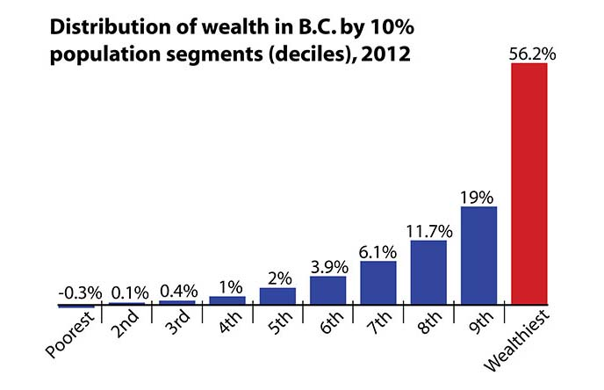

The figures, in this case, were derived a bit differently. Statistics Canada survey data was used to calculate net wealth ie the money a family would have if they sold off all their assets and paid off all their debts. The median (midpoint) net worth across all BC families is $344,000 (well above the Canadian median of $244,000, partly reflecting salaries and property values in BC province). The richest tenth have, on average, net wealth of $2million whilst the poorest tenth have, on average, net wealth of -$10,000 ie they have more debt than assets (and that is an average, so the people at the lower end of that tenth are in real financial troubles).

Canada is always a useful country to look at since, as we will see later, it is averagely representative of many western developed countries.

Put the Canadian figures another way (and one of the problems is that the same reality can be presented in several different ways): In 2013 the Canadian median (mid-point) income was $27,800 per year. The average person in the richest 1% of Canadians earned 7 times that figure – ie, somewhere in the region of $191,000/year. The richest1% are quite a small group and, whatever one believes about the rights and wrongs of having differences in income, for that select little group to earn so much might not seem too excessive to some but might feel a travesty of social justice to others.

Here is a different statistic: The richest 30% of Canadians get 56% of income. Fair or not fair? The figures don’t look too extreme but put another way mean that the richest third take two-thirds of the money. That sounds far worse. But include the statistic that the same richest third pay almost three-quarters of the total income tax, and it begins to sound reasonable again to many people. How about ‘Top 10% receive 28% of national income and pay 42% of nation’s income tax’?

By now I am beginning to feel baffled by all the different ways that figures can be presented and – unless I can fall back on some absolute moralities (such as: Everyone should be Equal) then fairness begins to feel a bit of a slippery notion.

So, what do we take from all that?

* Simple headlines can generate strong reactions.
* Situations are sometimes more complex than the headline or graph suggests.
* Most people have some ingrained sense of what is, or is not, fair.
* What is fair or unfair will be a matter of differing opinion for different individuals.
* Some countries, however the figures are put, still seem more ‘fair’ than others

I want to move away from isolated media headlines and look at a couple of pieces of more detailed research. Two books have captured attention over the past three years. Both deal with the analysis of economic data and draw conclusions that have made politicians, policy makers and academics pay attention.

One is ‘The Spirit Level: Why equality is better for everyone’ by Richard Wilkinson and Kate Pickett. The other is ‘Capitalism in the 21st Century’ by Thomas Picketty.

They are two quite different books. ‘The Spirit Level’ is an easily-carried, widely-read book. It takes a snapshot of formally-reported data on national-level income per head of population for many countries and looks at how this figure might be related to other national data for each country. Its authors have put much of the background data-work on a website at [www.equalitytrust.org.uk](http://www.equalitytrust.org.uk). This site contains the charts that will be used below. If anyone is interested in digging deeper into their work, looking through the data, or scanning more charts then I would encourage them to buy the book and/or visit their website.

‘Capitalism in the 21st Century’ is a large book, more than 600 pages of detailed argument, with footnotes to the work of others. It is respected as an academic, rigorous, compelling work. It takes a long-term view of changes over time. Each book makes its own useful contribution to how poverty might be thought about and analysed.

**Financial inequality and its impact at national level**

Let’s start with ‘The Spirit Level’.

It is possible to take standard-reported data on national wealth per head of population and plot this against other factors, such as life expectancy (A useful measure because life expectancy can be seen as an outcome of a whole range of contributory factors such as access to education, access to health care facilities, ease of transport in times of illness, quality of water/air etc).

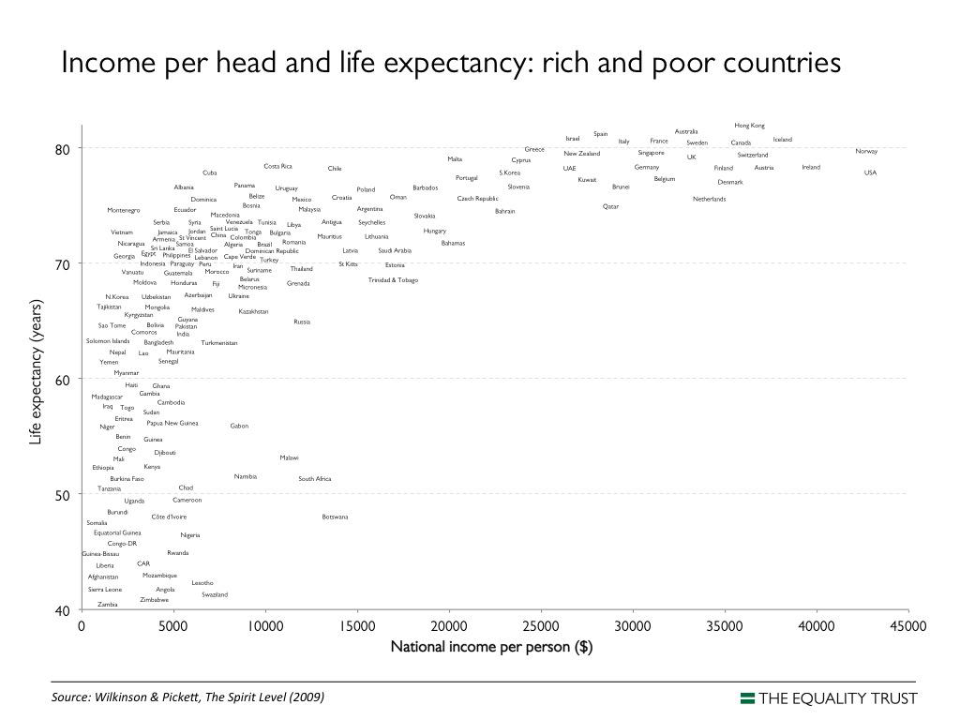

The chart above can be read in three sections:

1. A steep rise in life expectancy as national income (from trade, aid, investment etc.) increases towards $5000 per person. Small increases in national income produce large gains in life expectancy. (It is always interesting to look at countries that seem off-the-graph - eg South Africa has more than three times the national income of many other African countries for the same level of life expectancy – and to speculate why this may be the case).
2. A cluster of countries where national income is $5,000-$10,000 per person and where life expectancy is levelling off at the level of 70-80 years.
3. A whole set of countries where national income ranges from $20,000-$40,000 per person and where the increases in national wealth are adding a few years to life expectancy (each year gained relying on more expensive interventions). If there is additional wealth in those countries then it may be going on other things than those needed for basic longevity.

If we zoom in on that top line of 20-30 countries we see that they include a number of Northern European countries; together with Australia and New Zealand; Canada and USA; and a handful of others such as Hong Kong, Singapore, South Korea, Israel, Qatar, Brunei and the United Arab Emirates. These countries have similarities, in being economically-developed countries, but differ in one key respect. There are large differences in levels of inequality between different countries. Looking at how much richer the richest 20% of population are compared with the poorest 20% of population in that country we get ratios that range from around 4 times (Scandinavian countries) to around 9 or 10 times (USA/ Singapore) – with countries like Canada, Spain, France, Switzerland, Ireland and Greece holding the middle positions.

The writers then plotted the national income/person figure for these 20-30 countries against a combined indicator of the country’s health and social problems (ie a single figure derived from national statistics on several issues such as literacy level, infant mortality, murder rates, levels of imprisonment, obesity, levels of mental illness and so on). This gave a fairly scattered graph with no outstanding pattern – other than the USA, with the highest national wealth, and Portugal, with the lowest national wealth, both had very poor social outcomes. National wealth did not seem to be the determining factor.

The same indicator of social issues, for each country, was then plotted against the degree of inequality in that country.

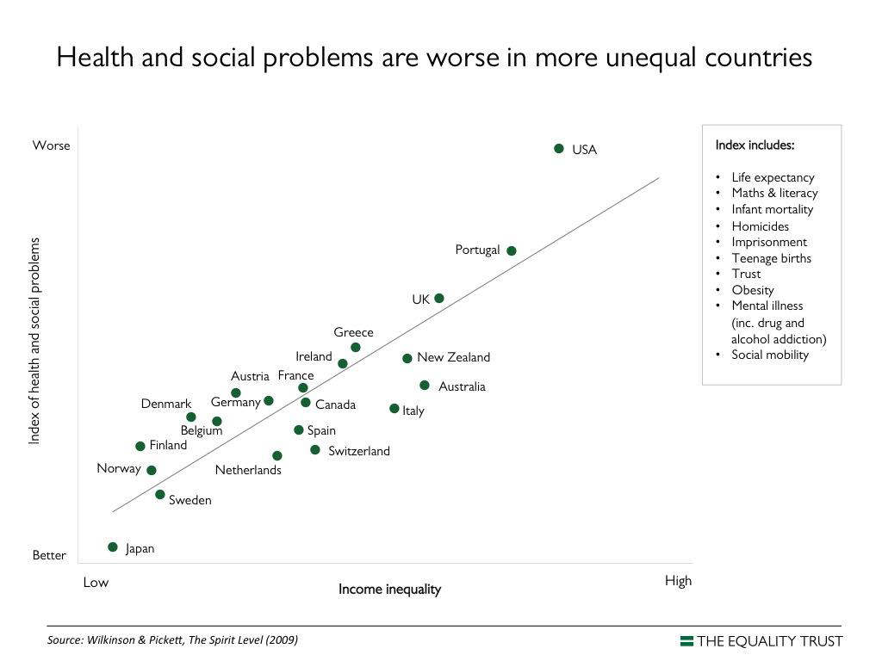

Whilst not a perfect fit, this chart indicated some relationship between inequality and social problems. The more unequal the country, the worse the social problems. This held true, to varying degrees, across a whole set of other measures, such as a measure of child well-being in each country.

This wasn’t because of the nature of the country. Japan and Sweden were the two countries where the gap between richest 20% and poorest 20% was least – but the two countries arrived at that position by quite different social/economic/ wage and tax structures. Similarly, to demonstrate that the poor social rating of the US wasn’t simply something about ‘being American’, ie a national culture thing, the researchers plotted the social rating against the level of inequality for each of the US states and found the same pattern: The more income inequality in a state, the higher the level of social issues.

(This was possible because of the large size of US states – almost the size of countries. The same may not apply below national level for other countries eg trying to compare regions or provinces. At that level other factors start to come into play).

There are rich countries and there are poor countries. However, it is not the level of overall national wealth per person that correlates with social gains/problems. It is the degree of income inequality that matters.

What can be done to reduce inequalities in a country, and thus gain better social outcomes? The writers of ‘The Spirit Level’ identify some things that can reduce levels of inequality. These include:

* Higher minimum wage for the lowest paid
* Generous pensions
* Low unemployment – more people in work
* Strong bargaining power of workers
* Good labour laws
* Political will to reduce inequality

**How is inequality changing over recent years?**

Let’s move on to the other book: Thomas Piketty’s ‘Capitalism in the 21st Century’. Rather than using snapshot data this takes a view of changes over time.

Anyone familiar with television programmes such as Downton Abbey will recognise the portrayal of social hierarchies with the rich landowners connected into national politics and decision-making, directing the employment of poor people who live as tenants on the landowner’s estate. From that 1913 era the income/wealth gap between the richest and poorest in society closed steadily up to the 1970s. This was not a result of the rich giving money to the poor, but was a result of more structural changes – world wars, the growing engagement of women in the workforce, the growth of consumerism, and so on.

Piketty tracked the changes in the gap between richest and poorest over the thirty years since that point ie from mid 1970s to the lead-in to the recent recession. He identified some trends.

Over this period, income inequalities increased sharply, in more countries, and were still accelerating. There was a dramatic rise in the share of total income going to the high-earners (eg In the US, 60% of that thirty year’s growth went to the richest 1%). Partly this was due to soaring salaries for some (top executives, top bankers and financiers etc). For others it was due to rapid income changes resulting from having usable capital wealth.

Again, simple data sets can hide more complex situations. Talking about the ‘richest 20%’ over a period of thirty years might imply that this is a stable group. Other information shows that, whilst the ‘top, top few percent’ might remain stable, membership of the various income categories can change in terms of individuals. The trends remain, however: The richest 20% group (whichever individuals are in it) are, over time, pulling further and further away from the average.

As an example, over the most recent years 1992 to 2007, the 400 highest earners in the US saw their income grow by nearly 400% and their collective tax bill reduce by 40%. This increased wealth could then be invested to create more income.

The trend is still continuing today and some mechanism is feeding it. He offers some clear solutions – such as an adequate tax on wealth – but there are doubts about the political will to implement these effectively. Unless something is done the future might be predicted as an extreme trend of some people more and more isolated in a super-rich celebrity/oligarch culture separated from, and oblivious of, society’s poor. This trend is already visible but, according to Picketty, can only get worse and worse unless some things are arranged differently. It becomes a matter of what kind of society we want today’s grandchildren to grow up in.

Whilst some people still argue for a complete overthrow of the capitalist system, more voices are now calling for a stronger distinction to be made between inclusive capitalism or exclusive capitalism.

Mark Carney, former governor of Canada’s national bank and now governor at the Bank of England, spoke at a recent Financial Times conference exploring the idea of inclusive capitalism. A more inclusive capitalism argues for a fairer relative financial equality within societies. This implies some sense of social justice and an attack on the extremes of inequality.

‘Fairness’ recurs time and again in the modern rhetoric of politicians – but, at the same time, any politician who starts to spell out what this might mean gets attacked in the press and in parliament for being anti-business, anti-success, and anti-growth. The use of ‘fairness’ as a smokescreen, whilst letting things carry on pretty much as before, is all part of the disenchantment with mainstream politics that is a growing facet in many countries. This has been described in terms of being ‘post-politics’ – parties are more concerned with focus groups, use of public relations tactics, gaining the few swing votes of the middle ground, capturing each other’s bits of territory, concern with being seen to respond to any issue of the day - and less concerned with what is good for the nation, or the world, long-term. For many, politics and economics have lost much of their authenticity.

In his speech, Mark Carney stressed that financial capitalism was not intended to be an end in itself but as a mechanism to promote investment, innovation, growth and prosperity. In the run up to the financial crisis, banking became too much simply about banks and financial products. This self-feeding world became based on things that were almost incomprehensible and which got stretched to breaking point. Mixed with outright fraud, cartels, rate-fixing and insider practices, the world of economics became seen as unreliable. A series of single actions set the whole thing into collapse-mode. As it unravelled, the effects were felt very strongly in countries with a dominant financial sector (UK), countries where debt had been packaged and repackaged and offered out way beyond people’s abilities to pay (US); but less so in other countries (Canada).

**Slumps, crashes and crises**

In the countries where the financial downturn was more marked, there were various responses. Initially there was genuine anger and calls for retribution – mostly against well-paid banking executives as private banks were bailed out using public money. In the words of one newspaper: “The crooks were gambling with our money”.

Later there was a sense of puzzlement. How did we get into a situation where we almost woke up one morning to find that bank cash machines no longer had the money to pay out to ordinary people using their bank cards? Why did no-one see it coming? Famously, in the UK, this was raised in a query by the Queen along the lines of: If you are all so clever, why did no-one predict the economic mess? In a letter to a newspaper, in response, a number of leading economists wrote that this was simply ‘the failure of the collective imagination of many bright people’.

More recently the economic downturn was seen as wider than just bankers’ bonuses. Yes, there had been a combination of greedy and speculative banking practices but this was alongside weak regulation of the financial systems (in line with a trend of general deregulation since the mid-1980s), plus the lack of concern by politicians who had become more concerned with instant-effect sound-bites rather than with examining long-term dangers.

Most recently, some writers have put the issue as one of domestic debt. In 2008 there was an economic belief that banks weren’t lending enough. As foreign money became more freely available, institutions started to ramp up the pushing of credit – multiple credit cards, subprime mortgages, multi-year ‘Buy now, pay later’ credit loans. People viewed houses as sources of profit, rather than as homes, stoking a housing bubble. Mortgages at 90% or more of earnings were promoted to feed people’s desire to get into the housing market. Once levels of domestic debt ran beyond all reasonable limits, mortgage repayments and houses became at risk, and the poor stopped spending as their wealth was in danger of being wiped out. Recession set in and unemployment followed. All of this credit-fuelled decline preceded the collapse of Lehman Brothers and other such banking issues.

Whatever the causes, as things went wrong the standard government approach across several countries was to bail out the banks – not bail out the debt-ridden public. Rebalancing the books then was seen as requiring a set of austerity measures, often disproportionately aimed at reducing state spending on support services and welfare. The poor were left poorer.

Within all of these economic changes, popular belief in the system was further undermined by a number of scandals:

* The deeper the failing of an organisation; the more the highly-paid chairs/chief executives got pay rises and bonuses (eg JP Morgan Chase)
* Banks were accused of malpractices or even of money laundering (HSBC)
* There was the exposure of instances of internal exchange rate fixing (Barclays)
* Following the excessive pushing of credit, banks were then further accused of mis-selling inappropriate credit-protection insurances (Many banks)
* There was the sorry tale of the chairman of a bank caught up in sex and drugs scandals; who then was shown to be a Methodist church minister … and all within a bank whose strapline claim was that they were The Ethical Bank
* There were even worse tales of UK Members of Parliament being exposed for cheating on claims for parliamentary expenses – the most famous example being one MP who claimed for a duck-house for the ducks on the lake of his country estate. When elected members ended up being jailed for fraud, some people wondered what kind of democratic country they were now living in.

The figures associated with the aftermath of the 2008 Great Recession in the US are staggering: Trillions of dollars erased from the economy; more than 50 million people thrown out of work; entire financial systems teetering on collapse; 8 million homes lost/foreclosed; bankruptcies galore; people in work having to take second jobs (where they existed) just to make ends meet.

**What impact did all this have on poverty policy?**

The publicity around the effects of inequality on the state of society; the publicity around the ever-accelerating gap between rich and poor; the sense that the richest financiers had somehow wrecked things and that poorer ordinary people were having to pay; the sense that the rich and famous could no longer be trusted to run things in the interest of everyone – all these combined to highlight the state of poverty in a number of countries and made people wonder about different ways of arranging things.

Poverty became the headline as a number of consistent statistics began to emerge across government and non-government organisation reports (even if each used different terms for poverty):

* + - * Up to one third of households can be described as ‘impoverished’
      * 1 in 6 people in work are now ‘poor’
      * 1 in 5 are in arrears with household bills
      * 1 in 4 believe they have less resources than they need to get by, day by day
      * 1 in 3 can’t heat homes properly in winter
      * 1 in 3 lack three or more ‘basic necessities’ (food, clothes, heating etc)
      * 1 in 3 have debts greater than their assets

Poverty could no longer be viewed as something that happened only to an unfortunate few. On any scale, 20-30% is a large chunk of any population.

With the political rhetoric of ‘All being in it together’, and the widespread belief that things had gone too far and some rebalancing was seriously needed, then surely the period after 2008 was going to be more equitable?

You might have thought so but, even in the more recent ‘recovery’ years of 2009-2012, the top 1% US incomes grew by 30.4% whilst the other 99% grew only by 0.4%. Across a number of countries, the richest 1% captured 95% of income gains in the first three years of recovery.

In the UK, in 2013, bosses’ pay surged by 21% whilst the average pay of their workers struggled to rise above the 1.5% inflation rate. This continued the trend of the widening gap between the pay of bosses and the pay of ordinary workers: Since 2000 the average earnings of large-company workers has increased by 48% but the pay of top executives increased by 278% - so that, whereas the bosses in 2000 earned 47 times as much as a worker, the bosses of 2013 earned 120 times the wage of a fulltime employee. We seem to be back at ‘Fair or Not Fair?’

Those are averages and hide some of the worst excesses: The hedge fund boss being paid £38million as a salary – 1,437 times the average UK salary of £26,500 – and that isn’t even in the super, super rich bracket. The system may have had a small set-back; it may have briefly missed a step, but it was soon back on track.

Going back, for a minute, to that ever-widening gap of Thomas Picketty, it not only raises the issue of moral fairness, it also has implications for social programmes. The rich are quite able, should they wish, to find ways of not paying any more tax than absolutely necessary on their increasing wealth. The poor, whose incomes are being depressed, are no longer paying the same level of taxes. The resulting reduction in tax incomes is starting to create policy problems for decision-makers. The wealth gap is squeezing revenues that state, provincial or national governments have available to spend on programmes for health, education, families etc..

Faced with all these kinds of statistics a range of people of influence have spoken more loudly to proclaim that something needs to be done: The list included a range of populist broadcasters and writers; Barack Obama, in his State of the Nation speech – identifying inequality as one of the key issues he intended to tackle; The Pope and other significant religious leaders identifying inequality and poverty as a key moral issue of our time; and even major financial regulatory organisations such as the International Monetary fund and the US Federal Reserve.

There were ongoing concerns to raise the standard of living of the world’s poorest but, additionally, there were increasing voices arguing that the aim in more developed countries was less about the absolute eradication of poverty and more about the reduction of financial inequalities.

The mood-swing has put poverty on high-level agendas in a new way. Sometimes the reasoning was that financial inequality seems morally wrong. At other times the argument was pragmatic: Inequality produces a range of social ills connected with poverty, each of which costs society to fix it. (“Gap between rich and poor costs Britain £339bn a year”). The pressure to meet those costs (or to contain the social ills) will increasingly be a financial burden on the rich. Everyone therefore has a vested interest in reducing poverty and reducing inequality.

Some have started to draw parallels between the inequality/poverty agenda and the global warming/environmental agenda:

There are those who believe it matters urgently and that radical changes need to be put in place; and there are those who believe that minor adjustments to the present system will get everything back on track. As things go on, such views can easily get more and more reinforced; more and more entrenched; more and more polarised.

To many, things seem to be getting inexorably more unequal day by day. There is a feeling that things are running away with themselves and getting more and more out of control. There is a sense that there is less and less time to make any necessary changes; but that effective action – or the will to take action – is far too weak, at too slow a pace and on too limited a scale to make the difference needed.

**Some of the things working against making progress**

At times the whole poverty debates feel like some political pantomime, as different sets of figures, or different interpretations, are shouted back and forth:

“Poverty has doubled!”

“Oh, no it hasn’t!!”

“Oh, yes it has!!!”

Or the terminology used to define and measure poverty gets too cloudy to understand. Poverty is officially defined as “Below 60% of median equivalised income”: Well that’s clear enough, then.

Or that key factors sometimes get included and sometimes get omitted, making direct comparisons difficult. Poverty is about income – but is that before or after tax; and before or after housing costs are taken into account; and so on.

Or, as connections are made between poverty and many other aspects of life, there is sometimes just too much terminology used around poverty:

People experiencing poverty can variously be described as poor; impoverished; below the poverty line; suffering in-work poverty…..

There can be relative poverty; absolute poverty; persistent poverty; Millenium-Goal defined poverty (‘$1 a day’ poverty); fuel poverty; food poverty; poverty in the midst of plenty … and that is before we get on to poverty of will; poverty of spirit; poverty of hope; poverty of ambition; poverty of control…..

Despite all the potential for confusion, at the end of the day, poverty is mostly about incomes – having disposable money or the lack of it – whether through wages or welfare or mixes of the two.

**A brief focus on incomes**

[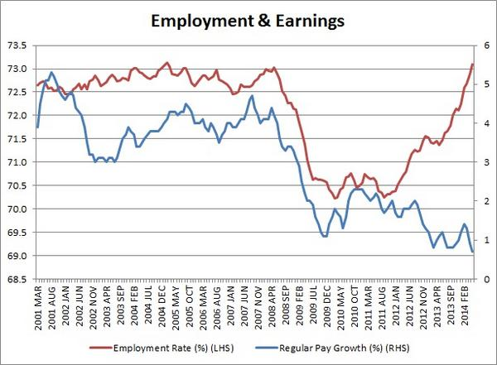](https://twitter.com/DuncanWeldon/status/489469002390188032/photo/1)

Charts like the above exist for most of the countries we have been considering. The exact graph line may vary from country to country but some recurring messages stand out. Rates of employment (the chance of being in a job) and rates of pay rises (the chance of earning a reasonable wage) follow similar trajectories until 2011/2012/2013. A different pattern then emerges. More people are now being employed but on lower wages. In the US, the rate of employment is now back up at (pre-Lehman) 2008 levels but wages are failing to rise.

Behind such headline statements (and we must always be careful with headlines) lie a series of structural changes in the patterns of employment. There is no longer any guarantee, in this new setting, that economic growth will end poverty. It is more difficult to earn one’s way out of poverty. Employment is a good thing but only so far as wage rates are adequate.

The mechanisms that disrupt the employment/earnings balance are several:

* More people have become self-employed and, at least in the early days, this may mean investing in the start-up at the expense of taking a reasonable wage.
* There has been a big increase in the use of insecure temporary contracts and low-hour contracts (even zero hours contracts – where someone may be on call to come in to do an hour here or a few hours there as work patterns demand).
* The use of unpaid internship arrangements has increased, as has the mandating of people on welfare benefits to take voluntary, unpaid work as a way of gaining employability skills.
* The loss of middle-skill jobs has meant larger numbers of people (without the high level skills to upgrade to well-paid jobs) have been taking any lower-wage jobs that do become available. Employers are under no internal pressure to set higher wages.
* The economic downturn has been seized as a business opportunity: a chance to squeeze wages (either out of necessity to stay in business or, unfortunately, to maintain or even increase profits).

Although there has been a recovery in the jobs market in a number of countries, this has not included all people. Those at risk of being shut out of any recovery include the long-term unemployed (There has been an 85% growth in this group in the UK over the past few years); young people wanting to enter the ‘real’ job market rather than be on employment programmes; and those who previously held low skill/low wage jobs. These groups are increasingly showing up in the lowest-income 20% of populations. There are certainly arguments that, where there has been a recovery, it has been a recovery for some not a recovery for all.

**Minimum wage, living wage and minimum income standard**

The existence of a Minimum Wage is common across many countries. The Minimum Wage is often set by a group who consider what the economy can afford. In the UK the Minimum Wage is set nationally. It is currently £6.50/hour for adults, with a lower rate for young workers. In other countries the rates of the Minimum Wage can vary by province or by city. There are those who argue that there could be Minimum Wage levels for different sectors (mining; construction; retail; etc). In most places the Minimum Wage is linked to the rate of inflation, so there are automatic rises every so often. Others are arguing that it is better to link the Minimum Wage to average wages. There are also differences in attitudes as to whether the Minimum Wage is a legal requirement in all cases, and the extent to which defaulting employers are chased with the full weight of the law.

One of the positives of setting a Minimum Wage is that it immediately dragged up the income of the very lowest paid. The negative is that there are too many people who stay on the Minimum Wage or just above – employers taking it as the level one has to pay. This needn’t be the case. The Minimum Wage in Britain is £1.40/hour higher than the New York equivalent and yet workers in the same hotel chain earn almost three times as much as their London wage-minimum counterparts because of better unionised wage deals.

The minimum wage is not enough, in a normal full-time job, to put a working adult above the ‘60% of median’ poverty measure. At the minimum wage someone may need to work around 50 hours per week to stay out of poverty. This often translates as two 25 hour/week jobs, with all the knock-on implications for family life.

In the UK some of the lowest paid workers are in the elderly care system. Not only are they paid at the basic Minimum Wage but they only get paid for designated attendance hours. This means they do not get paid for time spent travelling between home visits, or holidays. In order to fully cover all contracted work-related costs, the pay would need to be nearer £15/hour but less than 4% of funders cost their contracts at this level. Without adequate pay this sector is characterised by large numbers of lowest qualified staff and by high staff turn-over rates. This has knock-on effects of lack of continuity of care for vulnerable adults and extra social costs as poorly-attended people need to go to hospital.

A different approach is to work out a Living Wage rate, above the Minimum wage level, on the basis that the Minimum Wage is not usually sufficient to live on. Where a Minimum Wage is around 10 Canadian Dollars/hour the group calculating the Living Wage reckon that the level needs to be nearer 12 dollars/hour – an extra 4,000 Canadian Dollars/year. With things changing so quickly, progressive politicians are suggesting a local minimum wage of 15 dollars/hour in Vancouver, with a living wage of nearer 20 dollars/hour.

The UK Living Wage approach is paralleled by the Minimum Income Standard. This is the least someone needs to earn to cover an agreed basket of items. Rather than being worked-down from what the economy might afford, this minimum is worked-up (by a citizens’ panel) to establish the real costs of things that the general public deem to be necessary for a basic life. The list is not luxurious: no cigarettes, no dishwasher/tumble drier, very little alcohol, internet access and a mobile/cell phone (but no need for a land line as well), a public transport pass rather than any car-costs. It does reflect an adequate, but basic, living.

In the 1980s 14% of people were under the Minimum Income Standard. Now 33% are below that level. So poverty has more than doubled. But over that same period wages have fallen. So the median salary is less. So the poverty measure (60% of median income) has fallen. So the number of people defined as being in poverty (number with income below 60% of median) has fallen – Hence the pantomime of “Poverty has increased”; “No, poverty has reduced”. Both can be true at the same time. It all depends on definitions. Those living with the daily realities of poverty, however, have no need for any such definitions. They know only too well what poverty is.

**What about income from welfare?**

Again headlines and quickly-made assumptions tend to dominate. Here is one from a recent news article: ’Hell’s Angel killer claimed welfare benefits while on the run’. Such ‘Why is society paying welfare to these people’ kind of article have dominated for years. More recently there have been counterbalancing ones, such as: ‘The price for being on welfare: Physical and verbal abuse’. Increasing numbers are being pushed, by circumstances, into relying on claiming welfare for their income. At the same time, increasing numbers of claimants (including those with disabilities, but not pensioners) are reporting being attacked, or landlords refusing them housing, or banks being difficult with them – as a result of having the ‘welfare’ status.

In April 2013 a report was published based on analysis of data from the British Social Attitudes Survey for the years 1983 to 2011. The researchers wanted to see how attitudes to poverty and welfare have changed over the three decades. There was a shift from the view that society was responsible for poverty to the view that individuals are responsible for their own poverty. People believed that there was too much child poverty but saw the solution to this as lying with the parents rather than with society in general. Although people in 2011 were not optimistic that levels of poverty would improve in the near future, there was an all-time low level of support for more welfare spending.

The narrative of ‘scroungers’, ‘feckless poor’, ‘welfare cheat’, and so on, is alive and well and can sometimes seem to be reported at every opportunity by the media. Some people have made it their life’s work to denigrate the impoverished. Others are making it their life’s work to unravel some of these narratives and get to the figures behind them.

Fraud, for example, runs at less than 1% across the entire welfare system. Far larger are the amounts wrongly paid out in error. Larger still are the amounts left unclaimed by people for whom ‘being on welfare’ is too stigmatic.

Similarly, much is made of ‘people sitting on disability welfare for decades’ or ‘families parked on unemployment welfare for generations’. This is the story of Entrenched Worklessness. Looking at the figures reveals a different story. The overall number of people claiming incapacity benefits may have stayed roughly the same for decades but millions of individuals have come on and off that list as their circumstances change over a significant period. There are, in the other example, some families where an adult may have been out of work for most of their life. Of these there are a small number where that person’s son has been unemployed for a substantial period. The numbers are small. When challenged to find the mythical families where there were ‘Three generations of people sitting around dependent on welfare’ some researchers could only find a handful. There are some families with multiple issues, across a couple of generations, but when traced these make up less than 3% - and are families with issues of alcohol, mental illness, long-term limiting physical illnesses – and so on: Hardly the army of workshy malingerers that are presumed to make up the majority of welfare claimants.

The responsibilities around such stories lie mostly with those who use them to make political capital – but also, as I have pointed out to the people who have been interviewing me for the radio and newspapers, there is a responsibility on the press and on broadcasters to look at how their material supports or challenges such stories.

The welfare arrangements in many countries suffer from serious design faults. The current UK government is making a brave attempt at rationalising the many varying complexities in their system so that it works as one single payment to people rather than a number of differing payments, and copes with the majority of people who are in work then need a short period of welfare support before moving back into work again. The new design will also guarantee that people are always better off in work, so that there can be no perverse incentives for not being part of an economic society where they are able. The ambition is right. The practical difficulties of getting a nationwide, whole-population, computerised mechanism to deal with the fluid realities of people’s lives is already proving a huge challenge. As I have described in other places, there are also difficulties with the unanticipated consequences of what initially might appear to be very rational policy decisions.

The levels of welfare payments (at least in those more unequal countries we noted earlier) are deliberately set at levels that are minimal – and there are downward pressures even on these. Many people struggle but are able to get by for some time, so long as there is some stability in the payments. The transition from work to welfare and back again is one of the main difficulties of the UK system, as elsewhere. It is also currently a major cause of extreme poverty of those caught up in the malfunctioning bureaucracy. The other major cause of sudden collapse into welfare poverty is the practice of sanctioning claimants ie their payments summarily suspended for some perceived rule-breaking.

What kinds of things are welfare recipients sanctioned for? There are many instances. Some examples from recent press accounts include stopping welfare to someone who refused to take up a zero-hours contract as work (on the grounds that it was not real work); or stopping payment for non-attendance at a back-to-work interview (It turned out that this person was having hospital treatment and was too ill to attend); and so on.

Delayed payments, disputed payments, and stopped payments mean that the recipient is plunged further into poverty. Resilient as many people are, usually there are no savings to fall back on. High-interest short-term pay-day loans only make matters worse. Such interruptions and delays in payment is the most frequent reason given for take-up of things such as food banks.

Sticking to the rules is no guarantee of avoiding extreme poverty. A startling recent case was that of a person who was receiving the minimal amount of welfare; was paying the rent and other commitments; was trying to do what had been agreed at the back-to-work interview and had spent the last bit of money on copying more bio/CVs to send out to employers in case they had vacancies. This person was found dead, having not eaten for days.

Even so, further reductions in welfare are proposed – but for those in poverty. Increasingly people are pointing to other state payments as a form of ‘welfare’: allowing tax avoidance by the rich and by large corporations; grants and subsidies to businesses; public underwriting of private companies that are encouraged to take on running public services. These state pay-outs subsidise richness and are not under the same pressures as state payments to the poor.

Inequality, poverty, fairness, injustice: all now central to political debate.

**When thinking about poverty are we confusing equality of income with adequacy of income?**

What does an average wage buy these days?

The chart below compares changes in pay with changes in inflation. For most of the time the costs of goods and services are going up at a faster rate than wages. Buying power lags behind rising costs.



Wages are falling for many of those in the poorer third of the working population, but those getting increases are finding that these are still below the rate of inflation. So, whatever the average wage buys – it buys less these days as prices go up and up. From average changes over the 2009-2013 period:

Food costs up 10-15%

Social housing rent up 5-15%

Private housing rent up 5-20%

Childcare costs up 27-50%

Energy costs up 30-40%

Fuel costs up 5- 9%

Public transport fares up 15-17%

We are then back to the notion of poverty as having an income that is inadequate to meet the basic necessities – the lack of ability to adequately feed and clothe self and family, and the inability to heat and insure a basic home. Of course, any increases in the basics will have a proportionally larger impact on the lives of those with least money. Reducing the costs of the basics is one way to ease the pressure on the budgets of the poorer sections of society.

When looking at the rises listed above there is another puzzle. The changes shown are average ie within that period prices had rises and dips but the trend was ever-upwards. As the wholesale prices of fuel went up the costs to the consumer, understandably, rose. When the wholesale prices fell the costs to the consumer still rose. Fuel companies made huge profits, whilst the poorer groups in society had trouble heating their home, cooking food etc.. Asking why this was so led to people being branded anti-business, yet it is a very reasonable question for anyone interested in the causes of poverty to ask. Bold politicians are beginning to tackle these concerns and show themselves as representing the interests of the less-wealthy voters. This implies having stronger regulation of the markets that supply basic necessities, or some mechanism that prevents any price-cartels forming amongst a few established service providers. Even where there are likely to be some immediate fall in costs, the longer-term trend is for higher proportions of wages being spent on the basics of existence.

Other linkages can be made between basic costs and poverty. Tracking the prices of 94 key food items between 2002 and 2012 showed that the healthier foods were the ones that had increased most in price.(cabbage up 22%, tomatoes up 40%, fish up 72% …compared with pizza down 25%, doughnuts up 2% ….) This can leave those on a limited budget with a more restricted diet. Poverty cuts into health; poor health in turn cuts into ability to work. Poverty and a whole host of other social determinants become intertwined.

Maybe ‘poverty’ is the wrong term. Maybe, in 1941, FD Roosevelt had the better terminology when he spoke of human rights as freedoms – including freedom from want (alongside freedom of speech, freedom to worship, and freedom from fear). Maybe all of this is not a Poverty issue. Maybe it is a Wants issue: a Human Rights issue: the right to a basic standard of living.

**Housing as a particular case**

Housing is linked to poverty in a couple of very specific ways:

1. Poverty measures are linked to incomes – but this can be before housing costs or after housing costs. Housing costs eat enough into income to push people towards poverty.
2. Those with no poverty issues – those with excess wealth – are able to purchase additional houses and rent them out to get more income. They stay out of poverty but, in the very worse cases, push others into poverty by charging excessive rents for inadequate premises.

There are a number of recent media reports that can link to this topic. The first is common to many places and is along the lines of ‘House prices in London are rising by almost 20% per year’. A second, connected, headline – also from the UK - reads ‘Houses earn us more than jobs’. For the first time, a landlord in a popular city like London can get more income from renting out a property than from working. This isn’t to imply that all landlords charge extortionate rents or prey on the poverty of others, simply to highlight one mechanism by which the richest 30% and the poorer 30% are kept financially separated.

There are then a number of articles highlighting the way spaces for rent in major cities are being divided into smaller units in response to the ever-increasing demand for housing. In the worse cases:

* Garden outbuildings have been roughly kitted out as basic living spaces and rented for around £600/month to those who cannot afford to rent elsewhere or who are refused housing because of being ‘poor’.
* Rooms have been split into two spaces, each about 10 foot x 8 foot – just room for a shower cubicle next to a sink, opposite a table and chair above which a single bed had been suspended from the ceiling. Toilet outside, down the corridor. Rent: £1000 /month. This takes such a chunk out of a likely renter’s income that what they are left with (after housing costs) may be almost too little to live on to stay anywhere but just above the poverty line – at risk of being knocked into poverty by the first challenge that comes along.

Collectively, examples like these last two introduce something else. Having stacked up a few different aspects to poverty and poverty-creation we must now add Greed to the list.

**Six reasons why poverty may appear to not exist**

Although the existence of poverty is taken for granted, almost an indisputable reality, there are people struggling with poverty who resist attempts to see themselves that way. They may have a number of rationalities:

1. We are not in Africa on $1 a day. That is the real poverty.

2. We don’t have a lot but I don’t feel poor; neither do my neighbours.

3. Being poor is part of life – even virtuous: something you struggle through life coping with.

4. I am £1 above the official poverty definition so I can’t be in poverty. This is the difficulty with relative poverty. £1/year above the line = not in poverty; £1/year under the line = in poverty. Yet those two pounds barely make any difference to people’s financial realities.

5. Others like me seem to be able to manage. If I were in poverty that would be because of some failing, some weakness in myself.

6. Attitudes have hardened: even if I were poor I wouldn’t admit it.

**Stocktake summary before moving on**

Using a range of information sources (media accounts, national reports and surveys, academic research…) we have seen that poverty can be thought of as an absolute – a line that people fall below; or as a relative – a difference in income/wealth between the richest and poorest sections of society.

At the national level we have seen that it is the size of this financial-inequalities gap that correlates with the prevalence of a range of social issues in the society. We have also seen that this gap was closing over a number of decades but has now widened again, and is continuing to widen at an accelerating pace.

We have seen that even where there has been a set-back to this accelerating trend, where there has been a financial slump, the process can quickly get back on track. The solutions to this situation can still be political ones but we may get to a point where runaway wealth differentials cannot be contained solely by political solutions.

There has been an early introduction of a set of ideas connected to poverty: Fairness, adequacy, want, greed…. and we have seen that approaches to poverty can be taken as matters of individual opinion or can be taken as matters of broader social concern. Poverty has become a more prominent agenda item for influencers, and the relationship of poverty to other things (housing, income, welfare etc) is spelled out more clearly than ever before – yet public opinion is being shaped towards seeing poverty as a matter of individual fault rather than social construction.

Underlying much of the work on poverty is a concern about the kind of society we are becoming (or have become) and what is acceptable /unacceptable in modern, twenty-first century, liberal democratic societies.

So far much of the journey has been around larger-scale economic trends, or national-level situations. In order to get a better fix on the impacts of poverty, it is reasonable to look in more depth at what happens within families, and particularly what happens around the development of children who are growing up experiencing poverty.

**Neuroscience and brain plasticity: Can we get inside the head of people affected by poverty?**

Is it possible to see the effects of poverty at the individual, and family, level and thus get clues as to what might be done to reduce poverty’s negative impacts (if we have the spirit and the will to do so)?

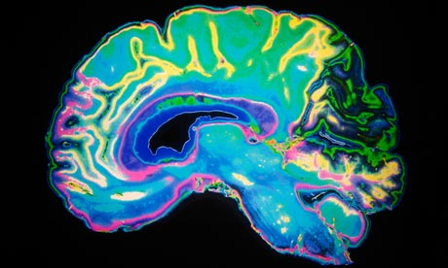

Understanding the mind is the new version of space exploration. One of the tools for this new exploration is the colour scan pictures of brain activity, like the one above. Science loves these. Newspapers and television shows love them even more. They are quick visuals around a commentary that usually goes: ‘Here is someone reading, look at how her brain lights up’. Or ‘Here is the brain of a person without our programme; and here is a picture of that person’s brain after doing our programme’, or ‘Here is the brain of an addict; and here is a normal brain’. It is a simple way of showing what is happening inside a person’s head. Except that things are never really that simple.

The pictures represent flows of blood, or nerves firing or other processes and these can then be related to the activity being undertaken. They don’t exactly explain the complexities of thinking.

There is a recent narrative linking poverty, brain development, neglect, and early childhood interventions. Governments in a number of countries have adopted a policy of strong intervention in the early years (0-5) in order to head off later, more costly, interventions as problems arise in some children’s lives. In itself this is a very sound approach. The difficulty is with some of the packaging that gets wrapped around it.

A key UK government strategy document setting out this approach was their 2011 report ‘Early Intervention: Smart Investment, Massive Savings’. The cover shows a scan of a normal brain of a three year old child alongside a bar of gold to represent the normal cost of providing services for such children. It also shows a shrivelled brain, full of holes, as the scan of the brain of a three year old suffering extreme neglect. Alongside this are the numerous bars of gold that will need to be spent to do all the remedial work throughout that child’s life.

Other reports and articles carried the same two scans and eventually there was the realisation that the same picture was being used and re-used whatever the context – but also that the scans were not of a normal brain and a brain showing some of the effects of neglect. The somewhat shrivelled brain was that of a Romanian orphan who had suffered severe sensory deprivation or institutional abuse.

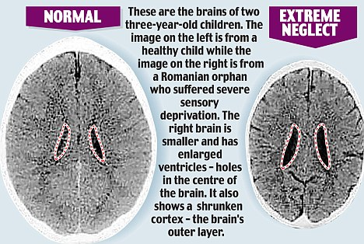

The first slippage was to jump from the extreme experiences of that orphanage child to make the assumption that similar damage was being caused by a mother who was nor fully-responsive, fully-cherishing of a young child. The next slippage was to make reference to this as ‘a child’s brain is set by the time they are three’, and to repeat this view within policy documents that were about poverty (rather than abuse or extreme neglect). The slide was to equate poor parents with neglectful/abusive parents. There is an ease with which extreme neglect has been made to stand in for average neglect, and then neglect made to stand in for disadvantage, which in many cases stands in for poverty. This is not to say that poverty has no effects on how a child may develop, it is to caution against easy slippages in language and thinking - particularly where these then get formalised into national or local policies.

So is there research on the effects of parents’ poverty on a child’s development? There are correlational studies (and I will have more to say about that later) where parents living in poverty for one reason or another tend to have children who do (on average) less well academically, are more likely (in general) to have low skilled jobs and earn lower wages. This inter-generational transmission of poverty has been the subject of a number of studies. The intermediary factors that make this outcome more likely than other, more successful outcomes, are being identified – but, again, as correlations rather than as definitive causes.

What about the effect of poverty on the brain of the parent? There are some experiments to indicate that where a parent is having to deal with all the extra issues that arise from being in poverty (Having to make appointments, but credit running out on phones, and little money for transport to get to interviews, so being late and missing the appointment, and thus welfare payments being stopped, creating more issues …. and on and on …) then the brain of that person can be saturated/overloaded by the poverty problems, meaning that other things slip and create more problems. So what may appear as inadequacy or lack of ambition of people dealing with poverty may well be something else.

**Families at risk of poverty and other limiting influences**

I will use another UK report to demonstrate something similar. This one was from the Cabinet Office and was titled ‘Families at Risk: background on families with multiple disadvantages’. This starts with families who have a lot of things to deal with – one of which is poverty. Over a couple of years the language slipped around to produce whole chains of different understandings.

‘Families at risk’ became ‘Families with multiple disadvantages (of which poverty is one)’ and then ‘Troubled families’ and then ‘Troublesome families’ and then ‘Problem families’. So, for some, it was a quick leap of the imagination from families experiencing poverty to problem families. Poor families became problem families. It was easy to also put this alongside the earlier-noted narratives of poor families being a ‘burden’ on the state and poverty being the fault of the individual. Getting the story back to one of families dealing with multiple burdens, and struggling hard to make a go of things, is not easy.

Surveying the sets of families who were experiencing multiple disadvantages showed that there were commonalities across them. The ones struggling most had several (but not necessarily all) of the following features:

* No parent in work
* Overcrowded living conditions
* No parent has qualifications
* Mother has mental health problems
* At least one parent has long-standing limiting illness or disability
* Income below accepted poverty line
* Inability to afford a number of everyday food or items of clothing

A similar list can be drawn up for families most likely to be experiencing poverty:

* Parent(s) not in work
* Lone parent families
* Teenage mother
* Limiting health or disability
* Mental illness – particularly of mother
* Large family
* Asylum seekers and refugees
* Homeless/traveller families
* Particular communities

Although the families were affected by a number of these features, most families are quite resilient. They can fairly easily deal with each issue as it comes along one at a time, or with two or even three problems at once. Throw three, four or five problems at the same family all at once and there is not the resilience to cope with all that and the family collapses.

So, we know the kinds of people most likely to end up in poverty. We know that they often have multiple disadvantages to deal with. We know that many cope with this but that a number sink under the pressures. We know that such people can be defined in ways that are not helpful to them. We know that there is a need to be careful with language.

Within such groups, is there an ongoing inter-generational process whereby the children of these poorer people are more likely to end up in poverty themselves?

**What can we learn from tracking families over time?**

I will stay with the UK for a while longer, partly because it is where I have had most experience of policy initiatives around poverty, change, families and children. One of the great resources the UK can draw on is a whole series of longitudinal surveys – tracking children’s experiences and outcomes as the grow up over extended periods of time. One example is the tracking of children all born in the same week in 1958. Those children have gone through the education system, been in the work system, established themselves as adults – many having children of their own who have also grown to adulthood. Tracking children from rich parents in 1958 and comparing them with children of parents who were poor in 1958 has been a rich source of information.

As with the earlier lists, much of this information is about correlations, likelihoods, probabilities – not certainties or predeterminations. It is also about types of people, groups sharing characteristics, averages across whole sets of individuals – not about each separate person. In what follows we may need to remind ourselves of that.

Studying the outcomes for groups of people over a lifetime begins to show a set of recurring messages. There are quite different life-patterns for cohorts of children of richer parents and cohorts of children of poorer parents. Taking the richest 20%/ poorest 20% groups of parents in the survey sample, it is easy to track what happened to their respective children as they grew, from their earliest developmental checks within the system (ie from around when they were three years old) to age 16 (ie throughout the various standard tests within the schooling system).

The group of children who, at age 3, were the ‘brightest’ (shorthand for most actively developed re the skills that would be needed throughout schooling) children of the richest set of parents tended to continue to do well all the way through the school assessment stages. In comparison (and as might be expected) the group of three year olds who were the least well ‘pre-skilled’ children of poorest parents tended to have some of the poorest outcomes throughout their school career.

What of the ‘brightest’ children of the poorest parents? And what of the group of least-developed children of the richest set of parents? One key set of studies showed that by age 5 the paths of the two groups cross and the ‘less able at age 3’ children of richest parents start doing better than the ‘more able at age 3’ children of the poorest parents.

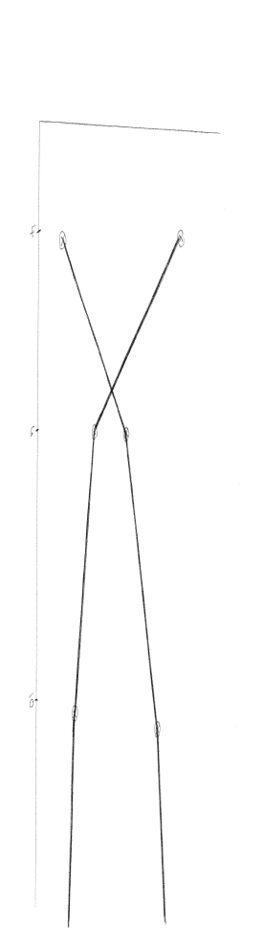

One explanation is that the poorest parents do not have access to the resources needed to foster continuing learning beyond certain levels whereas the richest set of parents are much more likely to drive their children from club to group to experience, and provide them with a whole range of things to support their further learning including access to private tutors, access to specialist advice and equipment, and so on.

Another (not necessarily mutually-exclusive) suggestion is that the richest set of parents is more likely to contain people with high levels of self-belief and their children are brought up with similar levels of self-confidence and high expectation. The poorest parents feel less control over their lives, have lower levels of self-belief that things are possible, and their family attitudes may be more characterised by low esteem, low ambition, low expectations, and so on.

Even where some of this research has been challenged this is not a reason to give up totally on such evidence or the logic behind it: Parents with more resources to invest in the development of their children are more likely to have children who succeed in school assessments. This is not saying that poorer parents do not have ways of investing in the stability and success of their children, far from it: but it is loading the academic- success dice in a certain direction.

It isn’t difficult to then couple all this individual and family-level influences with what has been said much earlier about the richest groupings and the poorest groupings in society getting disproportionate supports and resourcings from wider social events (such as national systems of wages and taxes; trends towards privatisation of services where money buys better outcomes etc).

There have been calls to focus more on early years, on family lifestyles, on childhood experiences etc. as necessary for tackling poverty. This has some attraction, and needs to be done in its own right – but the primary anti-poverty focus has to remain on incomes and expenditures (at individual, family, community and national levels). Money matters immediately.

Richness and poverty, and the gap between the two, look to be fairly well entrenched in society. Without getting too despondent about any apparent inevitability of poverty, things seem that they will carry on pretty much in the same ways unless there are determined efforts to bring in some changes. There are things that work in closing poverty gaps.

It takes us back to poverty of will, and to how we see society. Where there is money available for social purposes (eg from tax revenues) it can be seen as there to underpin collective social purpose or it can be seen as there to support personal or corporate gain. It depends on philosophical stances concerned with: What is life all about? What is the basis of human nature? What kind of society is it good to live in? Ultimately the solution to these, in practice, lies in the hands of politicians and economists but economics is too important to leave to economists without there being a moral dimension.

**What might be done?**

To cut through some of the confusions about statistics, it is possible to simplify poverty. Let us first and foremost see poverty as the lack of adequate levels of money to meet basic necessities for an acceptable lifestyle. As a general line, without overdoing the rhetoric, it is possible to say that poverty exists at unacceptable levels; that poverty is not inevitable; that gaps can be closed even if relative poverty cannot be eradicated.

Much of what will have the biggest effect is at the level of national or regional policy-determination:

* fixing parts of the tax-and-spend system – including ensuring that tax regimes do not disadvantage the poor and advantage the rich; that personal and corporate taxes are realistically paid; ensuring that revenues collected are directed back to remove some of the causes of poverty
* ensuring that there are sufficient jobs at adequate wages for those who are not in the high skill/ high wage group of future employment
* encouraging widespread family-friendly working practices by employers
* legislating against insecure working; unfair contracts; productive working relationships with trades unions to get more flexible working with security of employment
* creating an expectation of worker voice in key company decisions; and of low ratios of pay between top executives and average workers
* querying the profits made by public utilities and private companies where these profits are excessive and the basic services provided cannot be afforded by a large chunk of the population
* curbing the reliance on any single employment sector – particularly any over-reliance on the financial services sector. Ongoing regulation of activity within the financial sector
* challenging politicians and the media on their portrayals of poverty and poor people
* questioning the impact of each development to make sure that it does not further disadvantage those already struggling
* building enough homes that are at affordable rents and in good condition
* creating routes to skills and employability for those able to work – whatever their current situation
* creating subsidised childcare arrangements (an example is the recent UK political commitment where every parent gets 15 hours/week free childcare for all 3 and 4 year olds, and poorer parents also get 15 hours/week free childcare for any 2 year olds.
* ensuring that families most likely to be in poverty have support to move towards employment (and, where unable to work, have adequate financial and social support) – Such families include those where there are issues of alcohol/drug abuse, mental illness, or domestic violence; adults subject to frequent mobility and relocation; ex-offenders; adults with disabilities or long-term limiting illnesses; members of communities facing discrimination in terms of employment or where there are few experiences of working practices.

There are thus many things that need to be tackled nationally or at regional level. Whilst this is a requirement to bring about real changes in poverty and inequalities, there are other things that can be done locally.

Some of these more local actions will be to ameliorate the immediate impacts of poverty – food banks; clothes banks; banks of baby supplies; support with school uniforms/school activities; provision of breakfasts before the school day; holiday activities for children. These are vital lifelines for those immediately in poverty, but they do not offer strong structural changes to the ways poverty is produced and sustained.

If poverty is to be tackled more at its roots then there are other actions that can be initiated locally. Some of these actions aim to have immediate impacts on poverty. Some aim more medium term – focusing on young people at high school/secondary school or who are about to enter the workforce (some of whom will also about to be parents in the near future). Other things are longer term – setting younger children off on routes that are more likely to prevent them being adults grappling with the effects of poverty. These include a range of things that have been demonstrated to make a difference. None, on their own, will prevent people being in poverty – but collectively they form a net to support those more likely to end up experiencing poverty and create chances for them to get out of poverty, and stay out of poverty.

Actions that might change things immediately for those in poverty:

Establish a sufficient number and range of low skill/adequate wage jobs

Pressing employers to pay a fair, adequate,

living wage

Having outreach activities, via relevant community organisations working with the groups most likely to be unemployed, to find pathways for individuals to get employment-ready

Providing people in poverty with access to manageable finances (basic simple bank accounts, credit unions) and to advice on debt and money-management

Establishing programmes of housing improvements to reduce heating costs; pressing private landlords to maintain/ improve properties and charge affordable rents

Forming collectives that bulk purchase things so reducing costs for all, including those who might normally struggle to pay those costs (Some places are entering into community fuel deals etc around the established providers)

Actions with young people to lessen their chances of later becoming adults in poverty:

Provision of employability skills, linked to future likely job vacancies; Good advice and guidance for those leaving school/college to get them on realistic routes to jobs

Opportunities to experience the world of work: work-placements, work visits, talks by employers, building practical work problems into the curriculum.

Tracking of those young people who are not in education or training or work and getting them into appropriate provision

Mentoring support (using adults with work histories) to get young people into work habits

Creation of Apprenticeships linked to particular trades and professions

All education providers offering good , appropriate learning for those aged 11-18

Putting self-awareness and awareness of others into the school/college curriculum

Creating opportunities for young people to gain recognised Life Skills

Making sure that young people who need it get adequate and appropriate learning support

Recruiting (through incentives) the best graduate teachers to teach in schools with underachieving pupils

Encouraging young people to aim higher; activities to build self-esteem and ambition; awareness links with universities and major employers

Monitoring, at school level, the gaps in achievement between poorer/disadvantaged pupils and the average for their peers – with planned actions to close the gaps; and monitoring annually of how far the gaps have been closed

Setting aside some school budget allocation to be distributed to schools based on the number of poorer/ disadvantaged students on-roll – to be spent on activities that have a clear chance of improving the achievements of those students. (Such activities include the use of whole-class ICT such as interactive whiteboards; 1:1 catch-up sessions in literacy and numeracy; work with students to strengthen their self-regulation, self-control and planning; Peer tutoring where one student works directly with another)

Actions to set young children and babies on a better start in life with the long-term aim of avoiding later poverty as an adult:

Work to ensure that every elementary/primary school is a good or outstanding school (eliminating any great variety between schools)

Every poor child able to get good quality free hot meals in school

Schools agreeing to have simplified clothing requirements (school-wear that is readily available at low cost)

Building time in the school day/ school lessons for pupils to focus on the social and emotional aspects of how they learn

Pupils encouraged to develop higher-level thinking and problem-solving skills

All pupils able to get appropriate support for any particular needs that help their learning

Encouragement, from an early age, to aim high – be ambitious, widen the possibilities

Schools monitor the gaps in achievement between poorer children and the school average – with planned actions to close the gap, and checking of how far gaps have been closed

Engaging parents in the things that their child is learning at school; linking this back to enjoyable activities that parent and child might continue at home

Local fast-response solutions to family/child problems before there is a need for higher-cost, more disruptive interventions

Mechanisms that offer parenting support; based on being a good enough parent: not on over-complex things, but on the need for firm loving approaches, regular bedtimes etc. Giving parents more belief that they can shape the future.

Parents of babies/very young children given access to financial advice; housing advice; advice on routes to appropriate jobs; advice on childcare and child development

Advice and support to parents of children 0-4 on creating a productive home learning environment eg using books and everyday playthings with the child; encouragements re ‘talk to your baby’ ; creating an interest in everyday surroundings.

Good quality maternity care; additional family-nurse partnership arrangements where a mother may need additional support (starting during pregnancy and offering consistent contact until the child is a toddler) – the aim is to ensure a good caring attachment between the mother and baby, as well as support with any issues.

This is a long list. No-one said that permanently closing the poverty gap was quick and easy. None of the things on the list are difficult to attempt and the outcome is certainly worth the effort. Doing all of these – at national and local levels – may still not get rid of all instances of poverty but will create a much better chance that:

* as few people as possible fall below the income level needed for an adequate life
* work pays a reasonable wage to all people doing a reasonable month’s work
* people have few unnecessarily high expenditures giving more people more choice on how they spend their money
* there is adequate support and income to those genuinely unable to work
* young people have a better chance of avoiding poverty in the future
* any gaps between rich and poor get closed
* the number in poverty may reduce over time

Many places are about to start the run-up to some significant election or other. We have said that a great deal lies in the remit of politicians (as well as the media coverage of election campaigns). Most politicians make serious statements about the social ends they want to secure, but are light on having clearly-defined policy mechanisms to get there.

It is not unreasonable to select a ‘top ten’ things from the lists above and, before the politicians have pinned everything down in their statements/ platforms/ manifestos, to ask each party what will be in their document - clearly and simply stated, as actions (rather than broad intents) – about each of the ten things; and, if elected, to know that they will be held to those actions.

**So, here at the end of this expansive exploration, what can we conclude?**

* There are many views: This is mine. There will be others. People have to work out their own position.
* Inequalities seem to have been around forever and poverty can feel inevitable but gaps have been closed (and been allowed to get wider). Things can be changed if there is the will.
* Not all countries, families, individuals are the same. Each has unique features. Each can find their own routes into poverty, and their own routes out of it.
* Poverty affects places and people. It can be studied, written about; researched; and be the subject of sessions like this one – but it is a tangible daily destructive reality for some people.
* Many agencies play their part: Politicians, banks, media, financiers, landlords, employers, educators, health workers, family support agencies …. Each can encourage poverty or work to reduce it.
* Some aspects of reducing poverty can only be solved at higher-level policy levels. There are other things that are effectively done by local agencies.
* There are trends across generations – different for rich and poor – but these can be changed by sets of well-planned, properly resourced interventions.
* It still comes down to money. The primary focus is getting adult incomes up for the poorest groups, as well boosting the potential earning capacity of young people, then protecting children’s longer-term likelihoods of not growing up to be in poverty later in life.

Geoff Bateson

(For a range of other writings by Geoff visit [www.thewordsthething.org.uk](http://www.thewordsthething.org.uk) )